📝 Notes
Jun 28, 2026

Cohort Call — Week 1 / Module 1 (Claude AI Certification)
Invited marianna.nechypor@gmail.com Rifat Erdem Sahin sudeunal3334@gmail.com
Attachments Cohort Call — Week 1 / Module 1 (Claude AI Certification)
Meeting records Transcript Recording Recording 2

Summary
The session covered the technical landscape of Artificial Intelligence and established the path for achieving professional certification.
Course Objectives and Philosophy
The training program analyzes Artificial Intelligence market demand to implement agentic business models that scale without traditional staffing. This methodology emphasizes utilizing autonomous systems to maximize operational efficiency.
Technical Foundations of Artificial Intelligence
Participants examined how Central Processing Units and Graphics Processing Units process data, while reviewing the critical role of context windows and token scaling. This technical proficiency ensures optimized resource consumption during deployment.
Certification and Automation Strategy
The group committed to following 5 structured modules to prepare for the 100 pound certification exam requiring a score of 70 to pass. Demonstration sessions illustrated how autonomous tools execute repetitive business tasks.

Next steps
- [Rifat Erdem Sahin] Upload Recording: Upload the meeting recording to the Google Drive folder for participants.
- [Rifat Erdem Sahin] Share Resources: Publish all course-related materials including the whiteboard link and project documentation to the communication channel and web page.
- [Sudenall] Complete Courses: Finish the free Anthropic AI certification modules on Skillshare.
- [Mariana Nechypor] Complete Courses: Finish the free Anthropic AI certification modules on Skillshare.
- [Marianna Nechypor, sudenall] Upload Usage Screenshot: Capture the usage screen and post the image on the designated board.
- [Rifat Erdem Sahin, Marianna Nechypor] Purchase Dublin Tickets: Buy the necessary travel tickets for the visit to Dublin.
- [Marianna Nechypor, sudenall] Pass AI Certification: Complete the required training and successfully pass the AI certification examination.
- [Rifat Erdem Sahin] Share Link: Provide the Hugging Face URL in the chat for future reference.
- [The group] Create Account: Register a new profile on the Hugging Face platform.
- [The group] Study Models: Review the various AI models available on Hugging Face before the next meeting.
- [The group] Study Exam: Prepare for the upcoming AI certification exam by studying the required material.
- [Rifat Erdem Sahin] Publish Content: Publish the module package on YouTube for public access.
- [Rifat Erdem Sahin] Share Training Link: Distribute the link to the training materials for student review.
- [The group] Complete Training: Finish the Cloud 101 video training course.
- [The group] Submit Inquiries: Prepare and submit questions regarding concepts not addressed by the provided training videos.
- [Rifat Erdem Sahin] Finalize Modules: Add images to the presentation and finalize the module package structure.

Details
Did the screenshots in this section make your notes better or worse?
- Meeting Logistics: Rifat Erdem Sahin apologized to the group for being late due to a prior meeting that ran over time. Rifat arrived at the meeting location, identified as Regal (Wetherspoons) in Cambridge, by bike. They explained that they had worked with Marianna Nechypor in the past and encouraged the participants to join in person at the venue for future sessions if desired.
- Technical Environment Setup: Rifat Erdem Sahin reviewed the technical requirements for the attendees, confirming that Sudenall had installed Docker Desktop and was utilizing a friend's paid Cloud account. Rifat provided a warning regarding the use of third-party accounts, noting that they often come with strict 5-hour usage limits and potential privacy risks regarding the visibility of search queries.
- Travel and Career Plans: Sudenall announced that they would be moving to Dublin, Ireland, in approximately three weeks. They expressed an interest in the Cloud certification, believing it would improve their career prospects by enabling them to integrate AI subsystems into future applications. Rifat highlighted that the group consists of immigrants, including themselves from Istanbul and Marianna from Ukraine, and emphasized that the group serves as a supportive environment for both AI-related and other professional questions.
- Audio and Connection Troubleshooting: Rifat Erdem Sahin experienced background noise issues at the public venue and discussed the use of an AI-based software called Krisp to suppress ambient audio. The participants navigated multiple device connections and Bluetooth troubleshooting to ensure clear communication for the duration of the meeting.
- Course Objectives and Resources: Rifat Erdem Sahin introduced the "Cloud AI certification for architects" program. They provided links to a GitHub repository, a presentation, and a whiteboard tool to facilitate the course. Rifat adjusted access permissions for the whiteboard to ensure all participants could interact with the materials immediately (00:04:13).
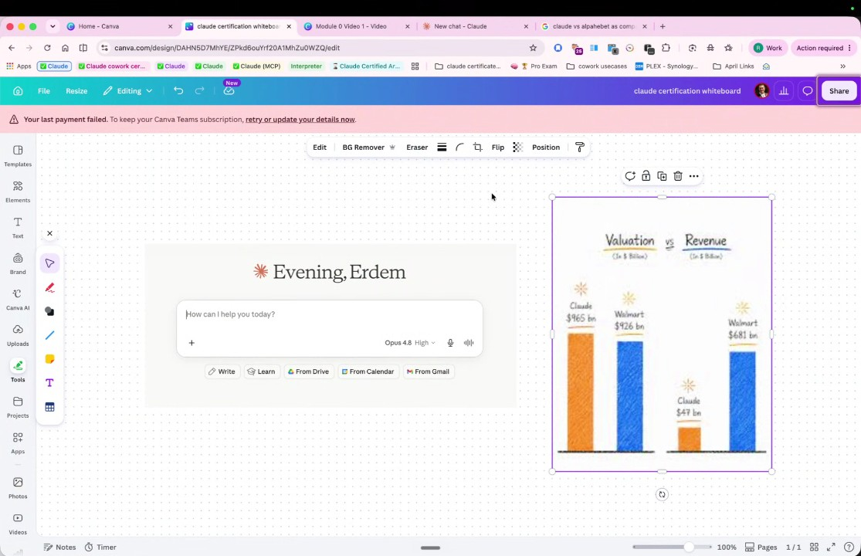
- Market Growth Analysis: Rifat Erdem Sahin presented data regarding the growth of Anthropic, the company behind Claude. They noted that Anthropic was demonstrating 400% year-over-year growth, which significantly outpaced the 18% growth of Microsoft and 22% growth of Alphabet, arguing that this indicates high market demand and effective technology (00:05:12).
- Professional Motivations: Marianna Nechypor shared a goal of using Claude to manage daily routines, build AI systems for business, and assist with digital marketing. Sudenall stated they wanted to demonstrate their knowledge of AI architecture to future employers. Rifat explained that their own motivation involves networking at the Venture Cafe in London and securing contracts with companies like IBM and Cap Gemini (00:07:31) (00:15:41).
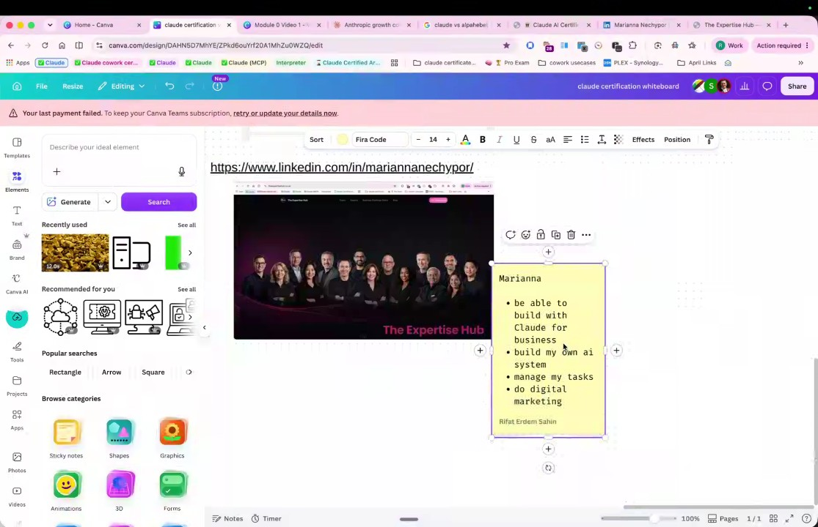
- Certification Value and Success Stories: Rifat Erdem Sahin referenced Bish Akardi, an individual who leveraged the Cloud AI certificate to become a partner, as a key example of the certification's career value. Rifat emphasized that in a field where many people claim to "know AI" without evidence, the certification acts as a critical, objective metric for verifying competency (00:09:37) (00:16:47).
- Training Materials and Tools: Rifat Erdem Sahin directed the group to free Anthropic-sponsored courses available on Skillshare and YouTube for foundational knowledge. Marianna Nechypor reported they had already started the Claude 101 course and shared that they use a tool called Lovable to assist with website design and development (00:10:58) (00:14:39).
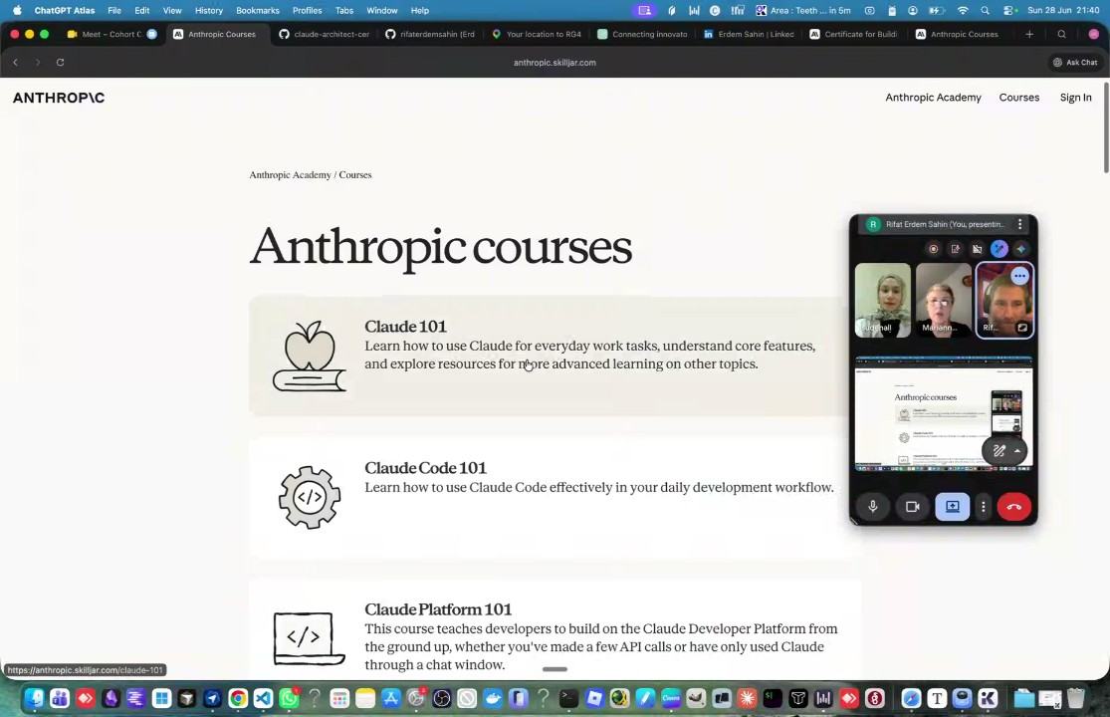
- Business Success Goals: Rifat Erdem Sahin disclosed a personal goal of achieving 10,000 pounds in business success through this course and jokingly challenged themselves to not cut their beard until this goal was met. The participants also discussed challenges related to internet connectivity at the public venue (00:18:12).
- Capitalism vs. AI Age Models: Rifat Erdem Sahin contrasted the "single-skilled" worker model, rooted in Adam Smith’s factory-based capitalism, with the "multi-skilled" worker model required in the age of AI. Rifat argued that AI allows individuals to perform multiple roles, such as design, coding, and marketing, effectively eliminating the need for a team of specialists (00:21:26) (00:28:13).
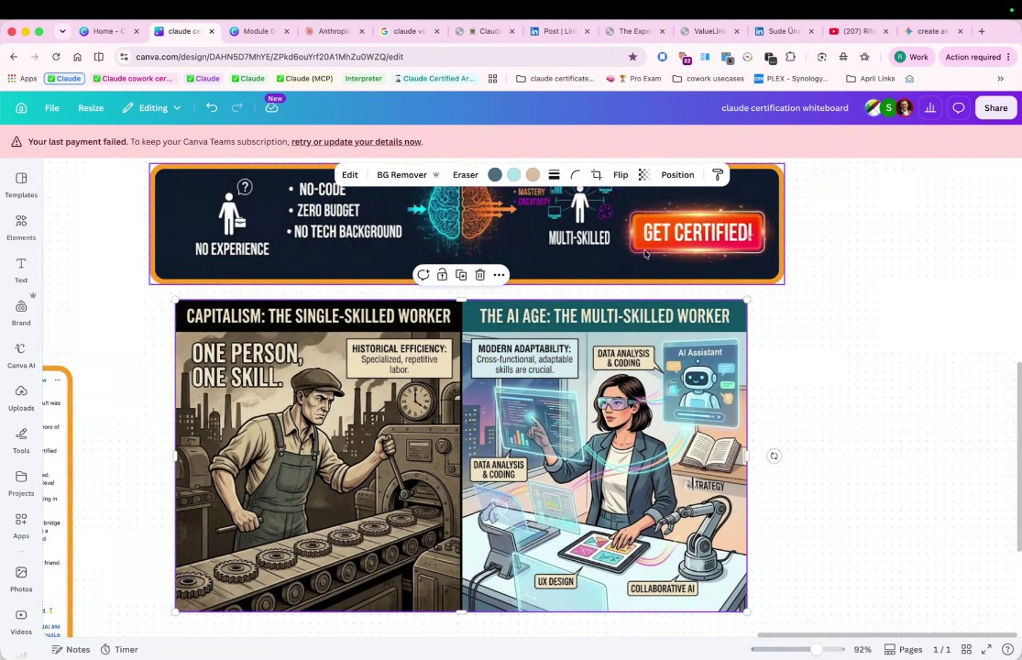
- The Paperclip Company Concept: Rifat Erdem Sahin introduced the "Paperclip" concept, which describes an "agentic" company structure. In this model, individuals use AI agents to automate roles like CEO, CTO, and bookkeeping. Rifat explained that this methodology allows for business scaling without the need to hire additional human employees, which serves as a primary driver for Claude's adoption (00:23:51) (00:27:12).
- Economic and Historical Context: Rifat Erdem Sahin compared the current AI adoption cycle to "cocaine dealers," suggesting that companies provide subsidized rates ($20) for expensive tools ($200 resource cost) to create dependency before raising prices. Rifat also used historical examples, such as the Ottoman Empire's struggle against European innovations, to illustrate that failing to adapt to new economic realities can lead to failure (00:30:27).
- Future Curriculum Scope: Rifat Erdem Sahin concluded the discussion by stating that the course would eventually expand beyond Claude. They intended to showcase other AI tools, including Google’s offerings and the Chinese system GLM 2.5, to ensure participants gain a well-rounded and versatile architecture skill set (00:34:58).
- Project Objectives and Certification: Rifat Erdem Sahin outlines the session's objective to create a project for Mariana that uses AI to generate posts. Rifat emphasizes that the participants should focus on understanding the material to pass the upcoming certification, which they describe as a valuable asset for their future careers (00:36:08).
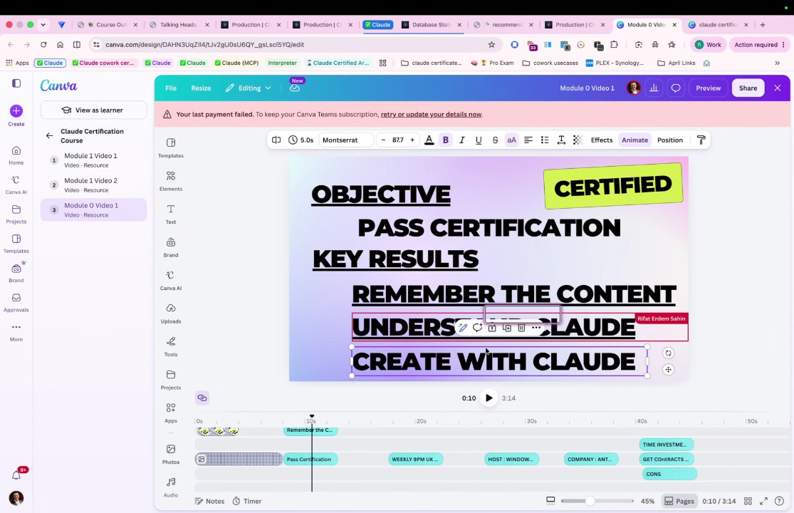
- Dublin as an AI Hub: Rifat discusses the importance of Dublin, noting that it serves as a major capital for European AI investment and data infrastructure due to favorable tax policies. Rifat proposes that they plan a trip to visit sudenall in Dublin, as it is a strategic location for the industry (00:37:59).
- AI as a Guessing Machine: Rifat explains that large language models function as guessing machines that predict the next word through tokenization and semantics. Because these models process context, they can successfully interpret prompts even when they contain spelling errors (00:38:54).
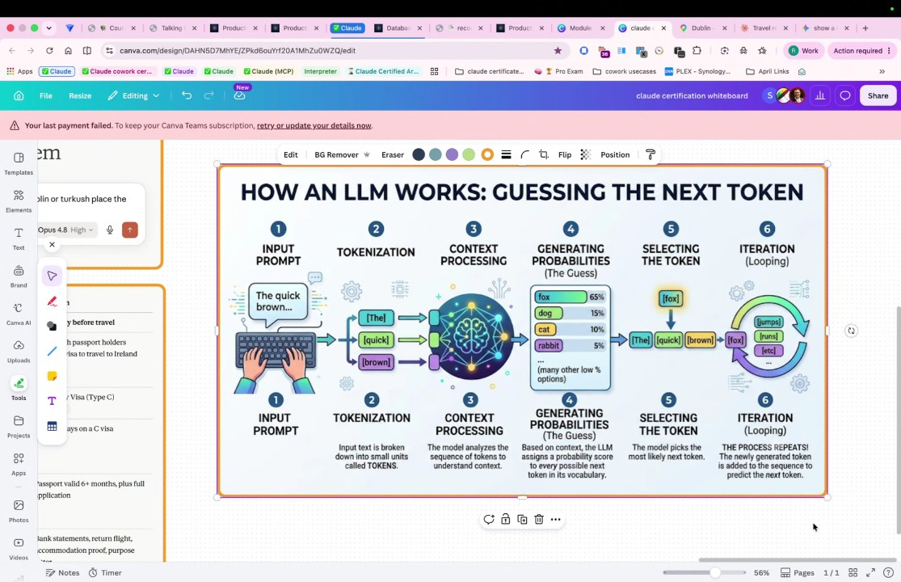
- Evolution of Language and Communication: Rifat discusses how AI-driven live translation tools are diminishing the traditional requirement for everyone to speak English to conduct business. Participants note that systems can now translate video and speech in real time, allowing people who speak different languages, such as Ukrainian, Turkish, and English, to collaborate effectively (00:44:53).
- Computing Power and GPU Usage: Rifat describes the shift from central processing units (CPUs) to graphics processing units (GPUs). While CPUs process tasks sequentially, GPUs process tokens simultaneously at high speeds, which is essential for the functionality of large language models (00:47:40).
- Monitoring AI Usage: Rifat emphasizes the importance of monitoring resource consumption and tracking token usage through the billing dashboards of AI platforms. Rifat notes that understanding the economics of these tools is critical for professional use (00:48:37) (00:54:41).
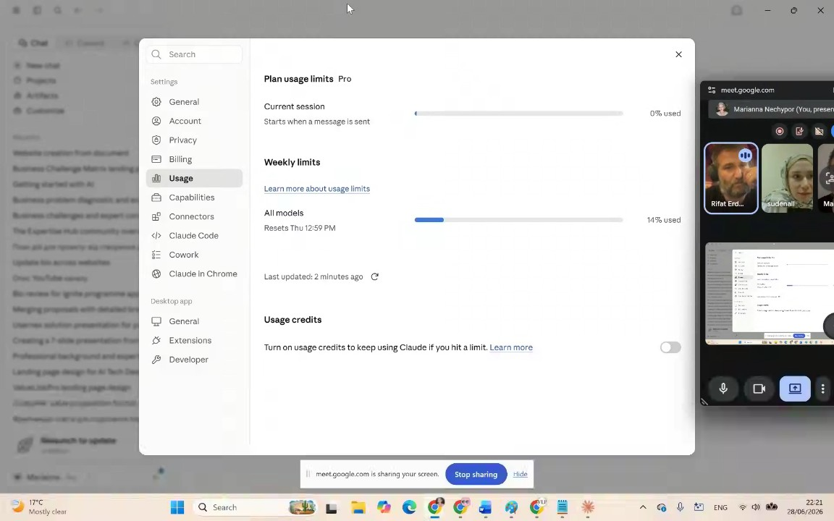
- Token Scaling and Efficiency: Rifat highlights the massive scale of AI processing by noting that they personally utilize approximately 50 million tokens per day. Rifat illustrates this volume by comparing it to the word counts of famous literary trilogies like The Lord of the Rings, explaining that AI allows users to create entire companies in a fraction of the time that it would take without such tools (00:55:40) (00:57:34).
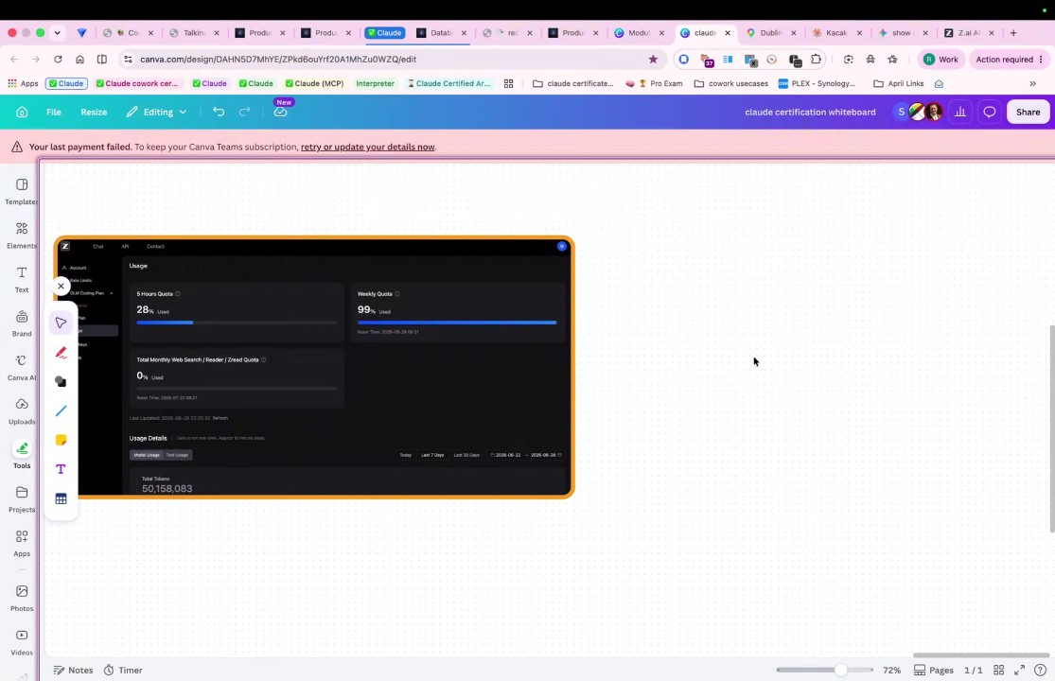
- Input versus Output Tokens: Rifat distinguishes between input tokens, which comprise the background knowledge and prompts provided to the model, and output tokens, which represent the AI's generated response. Rifat advises that since AI models essentially guess the next token, the quality of the output depends heavily on the quality of the input prompts (01:03:55).
- Context Size and Memory: Rifat explains that context size acts as the "memory" of a large language model. Larger context sizes allow the model to retain and utilize more information, though increased memory capacity requires more extensive computational resources and is therefore more expensive to operate (01:07:22).
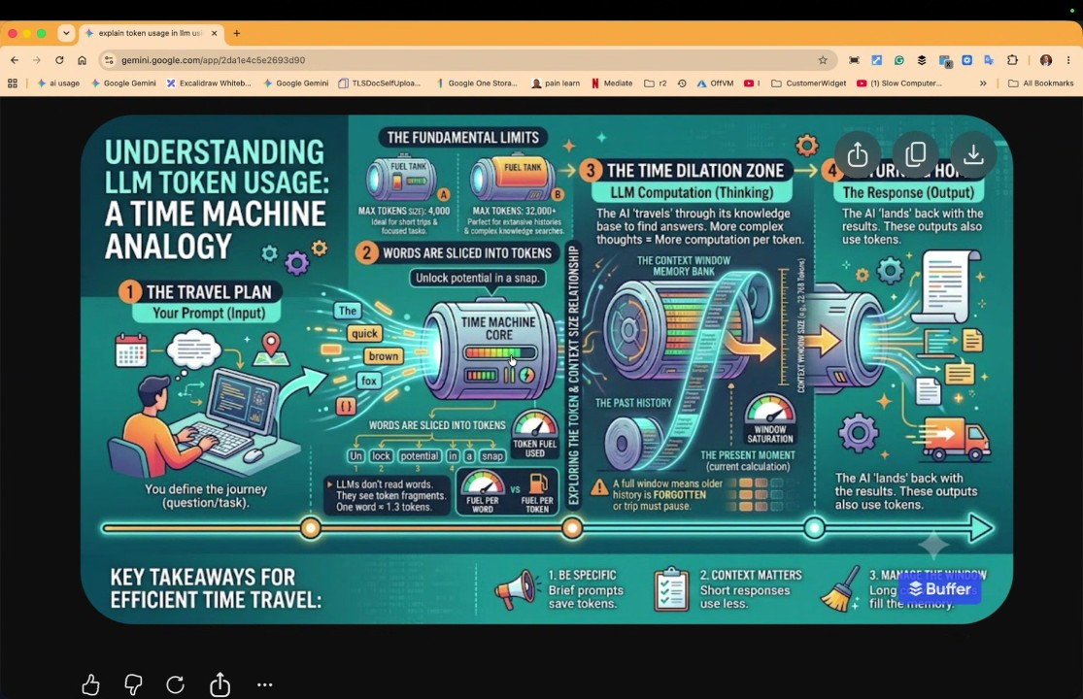
- Model Specialization and Hugging Face: Rifat introduces Hugging Face as a repository containing approximately 5 million different AI models. Rifat explains that while some models are general-purpose, others are highly specialized for specific tasks, such as identifying objects for military drones or performing medical diagnoses, noting that not all models are designed to be general "Einsteins" (01:09:45) (01:11:43).
- Commercial versus Open Weights Models: Rifat discusses the differences between commercial models like Claude and open-weight models like DeepSeek. Commercial companies often apply censorship and safety limitations to their models to protect their commercial interests, whereas open-weight models may lack these restrictions and are sometimes more efficient or cost-effective for specific technical tasks (01:18:24) (01:20:24).
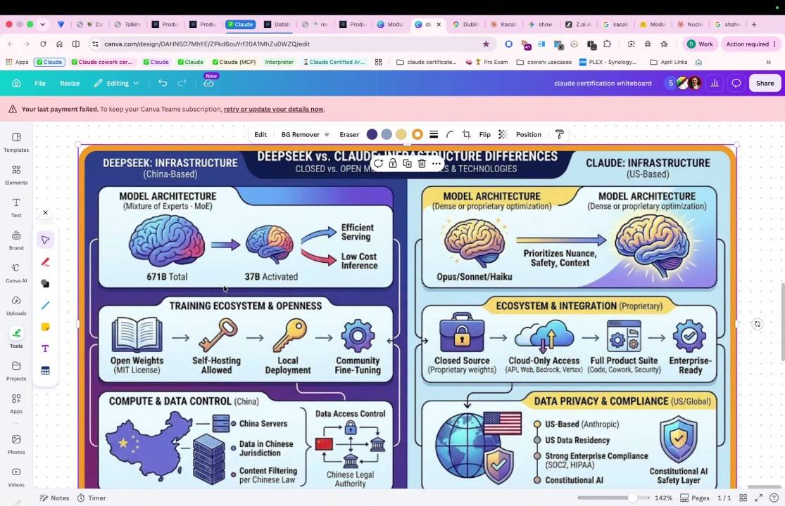
- Strategic Necessity of AI Adoption: Rifat asserts that in the modern economy, proficiency with AI is becoming as essential as basic literacy with calculators or spreadsheet software. Rifat warns that individuals who cannot think and work with AI will be left behind, as the new economy will require the integration of these tools for standard business operations (01:22:38).
- Automated Task Execution with "Cover": Rifat demonstrates the "Cover" tool within the software, which is designed to automate complex, repetitive tasks. Rifat shows how the tool can take control of a computer to navigate to LinkedIn, scroll through conversations, and send messages to contacts automatically, saving significant time for the user (01:23:36).
- Troubleshooting Project Creation: During a hands-on session, Mariana attempts to create a project for LinkedIn automation related to their "Expertisa" company but encounters a "Failed to fetch the project" error. Rifat suggests that they try creating a specific task instead of a project to bypass the technical issue and continue the hands-on practice (01:28:34) (01:31:13).
- Computer Control and Initial Automation: Rifat Erdem Sahin guides Marianna Nechypor through using an AI agent to automate professional tasks, such as sending messages regarding an expertisa speaker series (01:34:44). Marianna Nechypor expresses hesitation about granting the computer control, but Rifat Erdem Sahin emphasizes that the process is safe, requiring human confirmation at every stage, and includes a stop button to prevent unwanted actions (01:36:53).
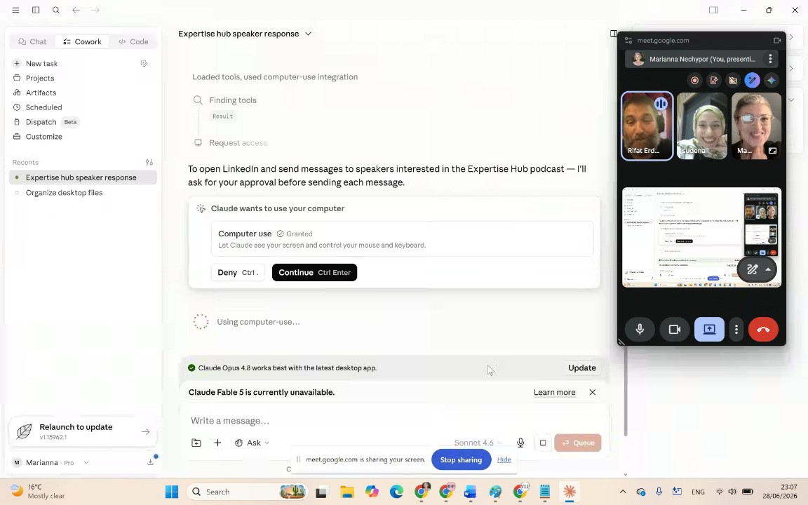
- Technical Troubleshooting for AI Integration: Rifat Erdem Sahin and Marianna Nechypor encounter issues with screen sharing and a Chrome extension, noting that the AI agent needs to be able to take control of the computer (01:39:51). Rifat Erdem Sahin insists on installing the correct Claude extension and opening a brand new Chrome window because the presence of too many active tabs prevents the AI from functioning correctly (01:40:58).
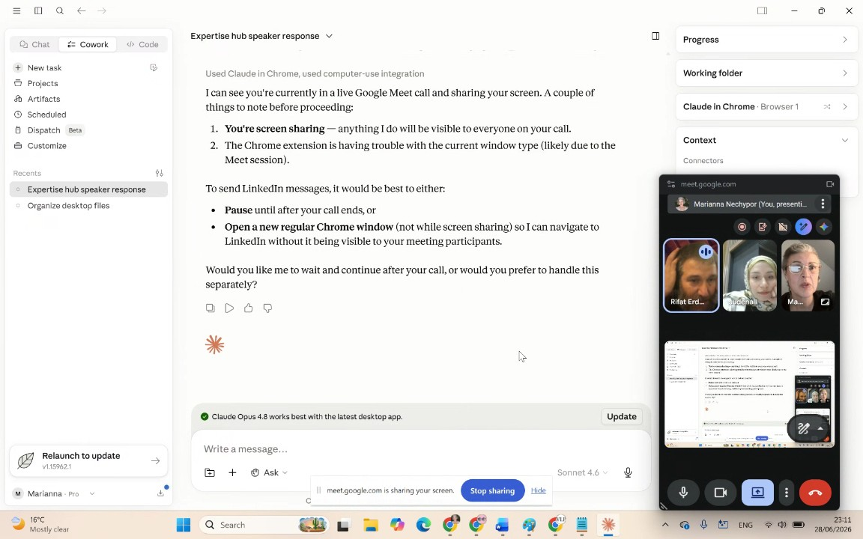
- Autonomous Agent Demonstration: Once the correct browser environment is established, the AI agent begins debugging and drafting a message to propose Marianna Nechypor as a speaker for the expertisa platform (01:44:08). Rifat Erdem Sahin highlights that the system operates in an autonomous manner, cycling through contacts while still allowing the user to review, verify, and edit messages before they are sent (01:46:32).
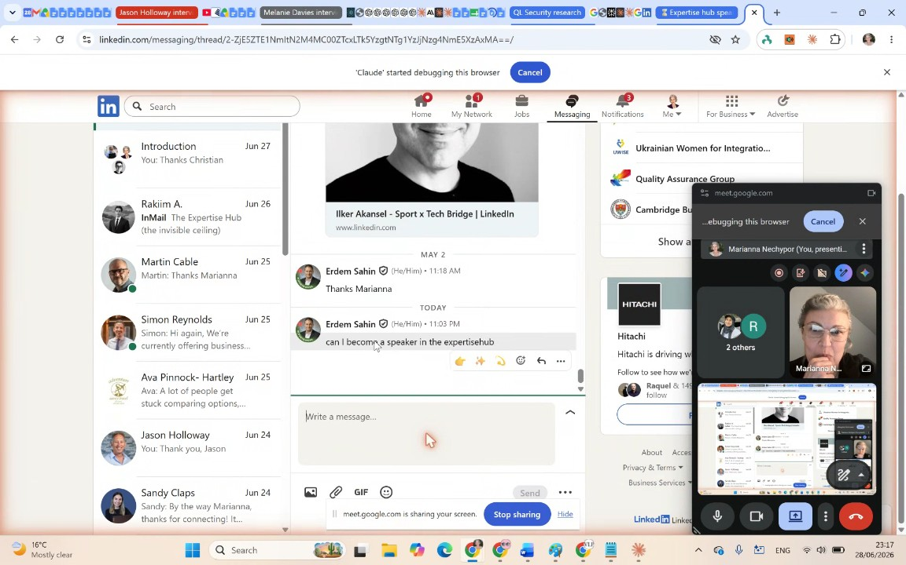
- Operational Costs and Value Proposition: Rifat Erdem Sahin discusses the cost-effectiveness of AI tools compared to hiring human assistants, noting that for $20, the system can handle significant tasks that would otherwise require expensive human labor. They emphasize that this technology allows for the automation of complex business operations, including running a company, managing customer relations, and coding (01:48:32).
- Certification Exam Requirements: Rifat Erdem Sahin details the requirements for the certification exam, noting that it costs £100 and a score of 70 out of 100 is required to pass. Rifat Erdem Sahin warns that failure results in a six-month ban from retaking the exam, emphasizing the need for rigorous study to prepare for this evaluation (01:50:00).
- Course Curriculum Structure: The training course is divided into five specific modules designed to build competency: the cloud ecosystem, Claude MCP, data privacy protocols, background automation, and financial engineering. Rifat Erdem Sahin plans to guide participants through each of these modules during weekly sessions to prepare them for the exam and real-world application of these technologies (01:54:17).
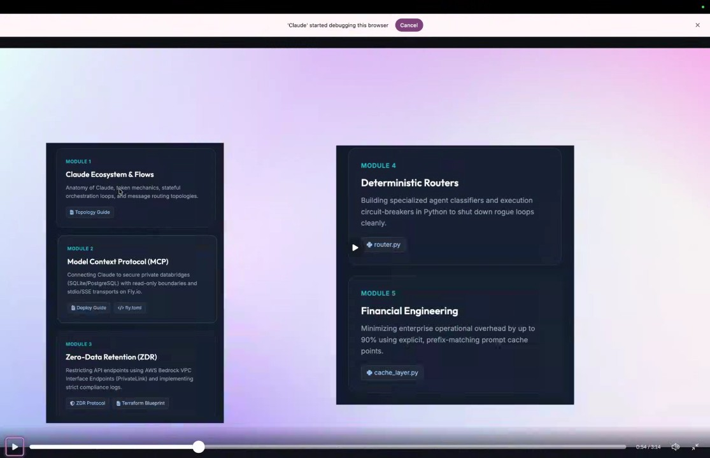
- Learning Strategy and Course Conclusion: To maximize the effectiveness of the course, Rifat Erdem Sahin advises participants to utilize the AI itself as a learning tool, asking it questions instead of relying solely on traditional search engines (01:56:22). Rifat Erdem Sahin explains that the business model involves providing a structured, condensed summary of complex concepts—derived from 10 hours of material—to ensure students receive a high return on investment and can guarantee their success on the certification exam (01:57:31).

You should review Gemini's notes to make sure they're accurate. Get tips and learn how Gemini takes notes
How is the quality of these specific notes? Take a short survey to let us know your feedback, including how helpful the notes were for your needs.

📖 Transcript
Jun 28, 2026

Cohort Call — Week 1 / Module 1 (Claude AI Certification) - Transcript

00:00:00

Rifat Erdem Sahin: uh being recorded on the top on here. So what we are going to look at everything that we are going to look at is going to be in my GitHub account that you guys should be able to go. I will put the links uh onto this channel and onto a web page. So it should be straightforward for everybody and I can also post the uh post the links on here. In this uh GitHub project, there's a readme and this readme has all the necessary links for us to be able to go to. I will post the first link. Uh Mariana,
Marianna Nechypor: Uh can you move us uh aside
Rifat Erdem Sahin: do you want to say something?
Marianna Nechypor: because we see ourself in the middle of uh the
Rifat Erdem Sahin: Yes.
Marianna Nechypor: screen.
Rifat Erdem Sahin: Off the screen.

00:00:52

Rifat Erdem Sahin: All right. I will close this.
Marianna Nechypor: Yeah. Yeah.
Rifat Erdem Sahin: This is better I guess.
Marianna Nechypor: Thanks.
Rifat Erdem Sahin: So I put the link uh to the repo.
sudenall: Yeah.
Rifat Erdem Sahin: So this is the project that I'm uh creating right now. So cloud AI certification for architects. Uh I hope you guys are able to see this. Is that correct? You guys are able to see it.
sudenall: Yeah.
Rifat Erdem Sahin: Yes. So I created a combo presentation.
Marianna Nechypor: Yes.
Rifat Erdem Sahin: I will go through it. But everything that you guys are looking for is in this website. I did also place a search on here. So you guys should be able to go through and be able to get this concept. Clo is one of the companies that is growing very very fast in the world. I created a presentation for this on here on KA. I will open this up and show this on KA.

00:01:48

Rifat Erdem Sahin: So the graphics is a bit bigger for us for today. Let's load that. So, come is an online tool if you guys didn't use it in the past to be able to do all these screen shares and to be able to do presentations with these. Hopefully, it does load. Yes, this is the module one uh module zero video one. I created all of them on here that we will go through this and I will uh open up all the necessary bits and pieces on here for us to be able to see and I will create a whiteboard and put all the notes on here and share the whiteboard link with you guys. So you guys should be also able to comment and the module zero model uh certification whiteboard. I will also put the whiteboard link over there. So you guys should be able to uh get to this whiteboard as well. I will put the chat. There's the chat.

00:03:00

Rifat Erdem Sahin: I will put the whiteboard on here. So you guys should be able to go through this whiteboard. So the company that we are looking into is this uh glo.ai. So this is right now a trillion dollar company uh for you guys info. So I will put the link on here. If we compare the cloud uh to Google, I will just go to Google images cloud versus Google. uh Google as a company company growth comparison comparison. So what we are trying to see it in here is clothes is one of the fastest growing companies in the world. Uh that this shows how fast the clothes is growing. uh it is an exponential growth uh as a company uh compared to other companies like Google or Alphabet as a company. So one of the fastest growing companies in the world uh is clo or I will put the image. reach uh the uh the combo link. Are you guys able to see the combo link?

00:04:13

sudenall: Yeah.
Marianna Nechypor: I was um requesting uh I requested
Rifat Erdem Sahin: So you
sudenall: Yeah.
Rifat Erdem Sahin: guys requested access. All right, I will put anyone with the link.
Marianna Nechypor: says.
Rifat Erdem Sahin: I will copy the link and put it one more time. So this time there should not be uh access requirements and you guys should be able to click and come to the boards.
Marianna Nechypor: Yes,
Rifat Erdem Sahin: So the program that yes I can see that Sudi is here and
Marianna Nechypor: I have it.
Rifat Erdem Sahin: Mariam Mar is here. Sudi if you click the link I will be able to see that you are also here as
sudenall: Yeah, I think
Rifat Erdem Sahin: well. All right uh all right I can see two of the people uh it's coming on here. So the program that we are going to do as I mentioned everything is on this website that we should be able to go ahead and get through this with this website. I will get the certification.

00:05:12

Rifat Erdem Sahin: So why do we need to get certified for the clo this world's fastest growing company in information technology? We are going to do a deep dive into this. Do you guys know why is this company growing very very fast? Do you guys have any ideas? Mara uh Sud do you have an idea why
Marianna Nechypor: No.
Rifat Erdem Sahin: this company is growing very fast?
sudenall: Maybe it requires uh a different architecture uh with respect to the
Rifat Erdem Sahin: for that.
sudenall: other AI programs.
Rifat Erdem Sahin: Yes, Antropic is growing uh compared to to Microsoft and Google in a table more than 10. So I asked the cloud itself why the entropic the main company is growing 10 times faster than uh the
Marianna Nechypor: Thank
Rifat Erdem Sahin: Microsoft and Google. This is a new world.
Marianna Nechypor: you.
Rifat Erdem Sahin: I'm asking the questions not to Google. In here, I ask the questions to Google. Right now, I'm asking the questions directly to clo to be able to get the answer and to be able

00:06:22

Marianna Nechypor: Thank you.
Rifat Erdem Sahin: to put this on here. I will put the image on here for you guys to be able to see. So, the entropics, Microsoft and Alphabets year or year growth. So the Antropic is growing five times faster than Google if you guys see the run rate. So the compared to Microsoft, Microsoft is growing 18%. And Alphabet is only growing 22%. This company is growing 400%. So what this means is uh this company Entropy is doing something very important in the marketplace. So it is outpacing most of the companies that we see in the market right now. So Antropic is doing something very very interesting in the marketplace. So it helps them grow this fast. So that is their rationale to be able to grow this fast. I will put the images to make sure that this is easier for you guys to be able to see. So this is a very fast growing company.

00:07:31

Rifat Erdem Sahin: So why do we want to be able to get a certification from this? What is your motive to get a certification? Mariana, what is your motivation uh to be able to get a certification from
Marianna Nechypor: to be able for my goal is to be able to use Claude as much as possible
Rifat Erdem Sahin: clo
Marianna Nechypor: for my routine.
Rifat Erdem Sahin: to be able to use it as a routine. What is your rationale?
sudenall: for me to it's same
Rifat Erdem Sahin: All right.
sudenall: way.
Rifat Erdem Sahin: My motivation is of course to use it. But right now I'm meeting with Claude every week, every Thursday in London in London King's Cross. I live in Cambridge. I will show the screen to give this a bit more context.
Marianna Nechypor: I love
Rifat Erdem Sahin: So I live in Cambridge here on Google Maps.
Marianna Nechypor: it.
Rifat Erdem Sahin: I go to Bingham uh every week uh on and if I take the directions from Cambridge from my location.

00:08:35

Rifat Erdem Sahin: Hello. While visiting this site, so this is a train ride for me from the middle of the UK. London. I stop in London and go to ready. And in London there's a place called venture cafe and the venture cafe is where most of the startups are coming in uh cafe uh London. I go to the meetups and in this venture cafe there is the clothes headquarters in this venture cafe and I'm going and seeing them. So for me it's networking, being able to build the tools with cloud and being able to get a customer with cloud. I'm working as a contractor. Uh I'm trying to land customers in the marketplace like Microsoft, like IBM, Cap Gemini. I would like to be able to get jobs and contracts using float.
Marianna Nechypor: upset. It's
Rifat Erdem Sahin: So that's my main rational.
Marianna Nechypor: using
Rifat Erdem Sahin: My main rational is not to use the code. I'm using the code a lot.

00:09:37

Rifat Erdem Sahin: Meaning uh if you guys look at my GitHub, I have around 363 projects around 400 projects. If there was no cloud AI, I will not have this many projects. So it does help me to be able to create a project, to be able to use the project. But what I'm at the end of the day looking forward to is I would like to be able to get the certificate so I can go through this process. Let's show you guys one person that has the certificate. Bish I put that on my LinkedIn on here as an activity. Bish Akardi. Can you guys see my LinkedIn?
sudenall: Yeah.
Rifat Erdem Sahin: I will put the post on here. He put this on here. He is a company and he's trying to become a clo partner. So he's taking this certificate the entropic certificate and being able to show it on his CV. Let's look at one credential from Antropic that the Antropic has these courses that you guys can go ahead and can complete and I will put these links uh the skill links as well onto the system so you guys can go ahead.

00:10:58

Rifat Erdem Sahin: Skillshar uh anthropic uh AI AI course these courses are free. You guys can go ahead and take these courses from Skillshare. I will put these are anthropics free courses. There is uh 101 I will put the link uh everybody please go ahead and make sure that you guys click the link.skillshar.com that is the anthropics main site uh to be able to get these courses. These courses are on YouTube and it goes through all the details that we will do in here uh together but if you guys have time sign up for the courses these are free courses. It will take you guys from one to one. Did anybody of you guys take these courses or nobody took those courses?
Marianna Nechypor: I started already. I've started the CL 101.
Rifat Erdem Sahin: H you started the skill.
Marianna Nechypor: I've started the CL 101.
Rifat Erdem Sahin: All right. Very good.
Marianna Nechypor: Yeah,
Rifat Erdem Sahin: Very good.
Marianna Nechypor: but Mhm.
Rifat Erdem Sahin: How did you find the course,

00:12:09

Marianna Nechypor: No, it's it's it's okay.
Rifat Erdem Sahin: Mar?
Marianna Nechypor: I started I I started only on the beginning with RP
Rifat Erdem Sahin: Yes.
Marianna Nechypor: configuration.
Rifat Erdem Sahin: And don't forget, I will write your goals on here as well. uh for Mariana and for Sud uh not a sticky note on here. Um Mariana said, "Do you want to be Mariana be able to build with quote?" Be able
Marianna Nechypor: to build with cloud.
Rifat Erdem Sahin: to build with quotes.
Marianna Nechypor: Yes. even for my businesses, you know, and even in in I think that in the future I will want to build my AI
Rifat Erdem Sahin: Yes.
Marianna Nechypor: system
Rifat Erdem Sahin: built my own AI
Marianna Nechypor: and for managing my tasks and for helping to do
Rifat Erdem Sahin: system.
Marianna Nechypor: social media market like digital marketing and um and uh like website development and um uh task management. ment like lots of things, you
Rifat Erdem Sahin: All right, let's show Mariana for Sud so you guys can meet
Marianna Nechypor: know.
Rifat Erdem Sahin: with each other a bit better.

00:13:29

Rifat Erdem Sahin: I will just put Mariana here.
Marianna Nechypor: Yeah.
Rifat Erdem Sahin: Mariana Mariana has a website and a YouTube channel and she is growing her uh the expertise up. I will put this on here. uh on here under Mariana. Uh Sudi, let's get your LinkedIn as well uh on the chat.
sudenall: Okay,
Rifat Erdem Sahin: But put your LinkedIn
sudenall: I will follow Mariana.
Rifat Erdem Sahin: uh all right.
sudenall: Okay,
Marianna Nechypor: Yes.
Rifat Erdem Sahin: I will put this like this.
sudenall: I'm opening my LinkedIn account.
Rifat Erdem Sahin: 20. So what Mariana will be able to do at the end of this courses, she will be able to come here and there's the the expertise hub, expertise hub on YouTube,
Marianna Nechypor: Yeah.
Rifat Erdem Sahin: the expertise hub
Marianna Nechypor: And I would like to to AI to use AI for developing videos etc.
Rifat Erdem Sahin: project.
Marianna Nechypor: Currently it's difficult for
Rifat Erdem Sahin: Yes,
Marianna Nechypor: me.
Rifat Erdem Sahin: I will go ahead and put this on here. You should be able to build this with the AI.

00:14:39

Rifat Erdem Sahin: Uh, let's put this next to it.
Marianna Nechypor: No,
Rifat Erdem Sahin: Build
Marianna Nechypor: I I am creating is with lovable this uh sites and value
Rifat Erdem Sahin: it
Marianna Nechypor: link pro. Have you seen my valink pro
Rifat Erdem Sahin: AI value link pro value link pro.
Marianna Nechypor: website?
Rifat Erdem Sahin: Uh, you are doing it with lovable and you want to be able to go to close uh
Marianna Nechypor: I I used clo already and I was building with
Rifat Erdem Sahin: value.
Marianna Nechypor: website for free on GitHub. I've I've done it like Claude created HTML and I've managed it
sudenall: Yes.
Marianna Nechypor: in GitHub before but still for now because I'm
Rifat Erdem Sahin: All right. Very good.
Marianna Nechypor: not because lovable helps more with the design that I stopped with
Rifat Erdem Sahin: All right.
Marianna Nechypor: lovable.
Rifat Erdem Sahin: Helps with the design. All right. Helps with the design.
Marianna Nechypor: Yeah,
Rifat Erdem Sahin: All right.
Marianna Nechypor: CL like does it okay but lovable for me or maybe I just you know it depends.

00:15:41

Rifat Erdem Sahin: All right. All right. Let's go to Suda. Sudi, did you share your LinkedIn?
Marianna Nechypor: Yes.
sudenall: Yeah.
Rifat Erdem Sahin: I will get the Sud's LinkedIn copy address. Uh, I will put them here. So, you guys should be able to add each other. Uh, Sudi is doing data mining and programming.
sudenall: Heat.
Rifat Erdem Sahin: I'll put Sudi here. Uh, Sud, you are looking to use the clothes at work. What else would you like to be able to do with
sudenall: Um actually I want to um demonstrate my knowledge of AI
Rifat Erdem Sahin: clothes?
sudenall: architecture to the companies I will work in the future. So I want to implement AI architecture in my future projects.
Rifat Erdem Sahin: Demonstrate expertise.
sudenall: Yeah.
Rifat Erdem Sahin: Uh, demonstrate expertise. That is very good. So your main thing will be close to Bish. Uh Bish uh what was Bish's last name? I will find Bish from my profile because he was there.

00:16:47

Rifat Erdem Sahin: So you guys want to be similar to Barish which put the he was Oracle. He put the cloud AI certificate on here. So people are coming to him to be able to uh give a job to Bish. So your use case is a bit uh close to Bish. If you are going to get employed by an employer, you will be able to show the cloud AI certificate foundations link on here. If you look at this, what he wrote this is uh this is his business and he is trying to do this with Hal a friend of mine as well to be able to get this certificate and people liking him and promoting uh over there to be able to do this. new certificate from world's biggest company uh on artificial intelligence in the enterprise the open AI is probably the world's biggest but in enterprise the entropic is having a big lead over here uh especially uh on the enterprise side so what we are going to focus on here is we will go through all in this detail I created marming video production I created lots of stuff to be able to create this as a course on pre-production, production and the post-p production.

00:18:12

Rifat Erdem Sahin: I will not take you guys through these but if you guys are interested in the future I will definitely take you guys this
Marianna Nechypor: internet
Rifat Erdem Sahin: website to be able to show all the use cases on
Marianna Nechypor: connection.
Rifat Erdem Sahin: here. What?
Marianna Nechypor: Uh we are losing you. Uh Adam, we are losing you from time to time. You know,
Rifat Erdem Sahin: All right. Is
Marianna Nechypor: Suda the internet connection in the UK is not the best
Rifat Erdem Sahin: it I'm in the weather sports.
Marianna Nechypor: really
Rifat Erdem Sahin: This is one of the reasons I did not want to uh make the kids not go to bed. I came to weather spoon so that could be the reason or I had the wire guard maybe that is enabled and active. Uh that might be the case but I think I turned it off open. Uh I will quit this one. I will create two networks in the background which could affect this call.

00:19:25

Rifat Erdem Sahin: Uh one of them is the wire guard. I will turn it off if that that could be the problem. I don't see that in the background but all right I will have it in mind. I will close unrelated programs that will consume my internet in the background. All right. Uh let's continue. So how we are going to get this certificate? Uh the reason I'm not cutting my beard is uh if I can't make this course a business success of this website uh of 10,000 pounds, I will not cut the beard. So that is my challenge. Did you get it? Uh was I clear? Mariana Mariana was buil Mariana
Marianna Nechypor: Yes, you are clear
Rifat Erdem Sahin: built uh training materials for enterprises.
Marianna Nechypor: in in the
Rifat Erdem Sahin: So for me it is a challenge in the past. So it is a challenge for me to be able to do this,
Marianna Nechypor: us.

00:20:23

Rifat Erdem Sahin: put this on a YouTube channel and to be able to market this with YouTube. But right now we are only going to focus on what you guys are going to see in here. Uh so our main goal is to become a float certified architect. Once you guys are an architect, you guys should be able to deliver everything directly on here.
Marianna Nechypor: He
Rifat Erdem Sahin: Uh you guys don't have to be extremely technically um qualified. We experience you guys not to learn the code. Uh we don't expect you guys to write code. We don't expect you guys to have a budget. We don't expect you guys to have the background. At the end you guys will become a multi-skilled person who will get certified and the end goal will be go to the clo certification exam and be able to pass the exam is our main goal for you. So this is the main goal for you guys to be able to go uh become a multi-skilled person.

00:21:26

Rifat Erdem Sahin: What is the difference between a multi-skilled person and a single skilled person? Um
sudenall: a multi-killed person can do uh can work in a different areas. So it's better for the companies I guess.
Rifat Erdem Sahin: Yes. During the times of capitalism, what happened is I will open up Gemini. Uh create an image show the capitalism. capitalism promotes uh promotes a single skilled worker worker where in the AI age the multi-killed uh worker will be important. Gemini uh nonobano to create an image to show the capitalism promotes single worker. If you come to the UK in Scotland there is Adam Scott uh Adam Smith that wrote the capital concepts wealth of nations why nations become
Marianna Nechypor: Jack
Rifat Erdem Sahin: wealthy and in his book he focused on uh
Marianna Nechypor: says
Rifat Erdem Sahin: the the in the audience to be single skilled. So what does a single skilled mean? Let's look at the single skill. You work in a factory and you only learn one skill.

00:22:48

Rifat Erdem Sahin: Can you guys see the screen? Is it big enough? So in capitalism, you only learn one skill. You are in a factory and there is historical efficiency on building these codes
sudenall: Yeah.
Rifat Erdem Sahin: while the person is building it. But in the AI age, it is changing. You are expected to be multi-killed, be able to do multiple things all at the same time. In the expertise of the Mariana should be able to do the design,
sudenall: Heat.
Rifat Erdem Sahin: should be able to do the coding, should be able to do the marketing using the artificial intelligence. This is called the company called the paperclip. Did you guys hear that term? Paperclip, Mariana. Uh this company is called a paper clip company.
Marianna Nechypor: Mm-
Rifat Erdem Sahin: Uh it's an AI concept. It is turning all the AI agents and build your company concept. I will put the image over here for you and turn it like a timeline.

00:23:51

Rifat Erdem Sahin: This is called a paperclip company. Mariana does not hire new people but builds her company on top of the AI. These are all the images that explains this. So what does that mean? Uh Mariana be becomes a multi-skilled person and builds all the different types of agents in her company. So let's go through this. This is called a build your AI agent and run your company. Instead of hiring a CEO, the CEO becomes an agent. Instead of getting a CTO, the agent does the work. Instead of getting a coder, the coder gets work. So what does that mean? Does that make sense with you guys or it doesn't? Uh having a agent CEO, what does it mean for you? S what
sudenall: having a agency. I I didn't understand clearly.
Rifat Erdem Sahin: does the CEO do in a company? Makes decisions. Chief operation uh chief executive makes the decisions.

00:24:56

Rifat Erdem Sahin: What does politicians do in a company uh in a government? They make decisions. What does an accountant do? They do bookkeeping. So in a paperclip company, what happens is a company's functions becomes agentic. It can work automatically. If it's a bookkeeper, it's going to do the books, do the tax submissions, do the banking. If it is a coding agent, it will write the code. If it is a CEO, it is going to make critical decisions for the company. So that's called an agentic company. The reason the clo becomes the world's fastest growing company is this paperclip concept because there is lots of people all around the world like Mariana who says I don't need to hire people. I can use the agents to be able to build my website, do my bills, make my decisions and deliver value for the customers. So that is the reason. So the the main critical thing is FL is able to do this on an agentic way.

00:25:59

Rifat Erdem Sahin: If we go in the past, if I wanted to be able to draw something like this, it will take me a designer to be able to draw this image. Mariana worked in the past for you to be able to get this will cost you hundreds to thousand dollars in the past. Is that correct
Marianna Nechypor: No absolutely correct.
Rifat Erdem Sahin: Mariana?
Marianna Nechypor: Previously I had a designer in my team takes time
Rifat Erdem Sahin: Yes.
Marianna Nechypor: conversation updating it was very expensive now and today I was surprised because I even don't have to uh to have to create because I'm able to create this AI can create for me from the
Rifat Erdem Sahin: PI
Marianna Nechypor: text for my LinkedIn post for example this AI is creating
Rifat Erdem Sahin: never
Marianna Nechypor: I'm just I creating the post and I'm telling AI please create the
Rifat Erdem Sahin: absolute.
Marianna Nechypor: picture especially for that post and AI is doing that for me personally or even I I'm hiring a person it will be difficult it
Rifat Erdem Sahin: I don't know.

00:27:12

Marianna Nechypor: will be expensive
Rifat Erdem Sahin: Yes. This is called a paper clip.
Marianna Nechypor: H.
Rifat Erdem Sahin: Attach in Turkish, paper clip in English. A basic concept to be able to hold on to your company.
Marianna Nechypor: Mhm.
Rifat Erdem Sahin: So what you guys are going to learn is it how to use clo how to manage workers in the company. It could be coder, it could be marketer, it could be CEO, it could be CTO, anybody in the company is going knowledge worker will become an agent and you guys are going to run
Marianna Nechypor: Mhm.
Rifat Erdem Sahin: the agent. So s does that mean the end of human labor
sudenall: No, actually because we need to uh steal humans for the manage the program
Rifat Erdem Sahin: manage the program but the clothes is getting managed not by you by somebody else.
sudenall: but for the control
Rifat Erdem Sahin: But uh Claude is going to I will show you guys that when I create my program, I have an error agent that looks at the errors, finds the errors, fixes the errors, deploys errors.

00:28:13

Rifat Erdem Sahin: I'm not finding the errors.
sudenall: What is
Rifat Erdem Sahin: I'm not controlling or monitoring the system.
sudenall: it?
Rifat Erdem Sahin: So most of the things that are done in the past are changing. But let's come back to Adam Smith's idea of single skill versus multi-killed. Once you guys become multi-skilled once they found calculators number of the accountants in the world did not go down there is more accountants in the world so Mariana will become a coder Mariana will become a CTO CEO Mariana will do everything in the company so that is the main concept that we need to get if we are going to get from the our initial section you guys are going to be multi-skilled person to be able to do this job. So you guys are going through that kind of a workflow for us and what is our objective? Let's look at our objective. I said passing the certification. Why do I focus on you guys passing the certification? Because if you guys cannot pass the certification, it means we just here and nobody measured Mariana.

00:29:23

Rifat Erdem Sahin: Mariana in her dreams is the best AI person. Is that correct Mariana?
Marianna Nechypor: Yes,
Rifat Erdem Sahin: You everybody can say I know AI.
Marianna Nechypor: absolutely. Yeah.
Rifat Erdem Sahin: Why do people like?
Marianna Nechypor: By the way, yeah, people are saying they they I know AI I use already.
Rifat Erdem Sahin: Yes.
Marianna Nechypor: Even they use just only chat, one chat, nothing else.
Rifat Erdem Sahin: Yes.
Marianna Nechypor: They are saying I'm using AI. I know AI.
Rifat Erdem Sahin: Such as Marian is coming from Ukraine. So the Putin can say I own Ukraine. But what changes? The other side does not agree that the Putin owns the Ukraine. So if you have the capacity, capability to be able to defend yourself, your skill, your future, then it means that you guys have learned it. Everybody can claim easily that they know AI. But this AI is something that is very very expensive and very effective. So the only way that you guys can claim that you guys know this is the certification.

00:30:27

Rifat Erdem Sahin: Why I am trying to emphasize this? This is very critical. Everybody in the future will say they will use the AI. Everybody goes to the university. Is that right? People in the white color labor goes to the university. But there is no distinction between the people. These AI systems are costing around. If you are using a $200 clothe model, it's costing around £4,000. If Marani is using a $20 clo model or Sudi is using $20 model, it is costing the clothes around $200 to run. Why are they giving this for you guys for free at a cheap subsidized rate? You guys know
Marianna Nechypor: cheap subsidized rate. Can you explain
Rifat Erdem Sahin: normally the clothes cost is $200 but they are giving you guys at
Marianna Nechypor: it?
Rifat Erdem Sahin: 20. Why are they doing that?
Marianna Nechypor: But they are making us dependent on their
Rifat Erdem Sahin: Yes,
Marianna Nechypor: system and we will pay much more

00:31:30

Rifat Erdem Sahin: these are like cocaine dealers. They are going to Yes, you guys have to pay much more later. It is like Uber.
Marianna Nechypor: later.
Rifat Erdem Sahin: Once Uber started, the rates were low. Then they lowered the pay for the drivers and increase the rates for the riders. So the capitalist will give the money in the beginning. So Mariana understands she can run a company. But once she understand she can run a company, she will be dependent on clothes. So that is very very critical. I will show the other AI operators 10 times cheaper Chinese operators as well. 10 times cheaper Chinese operators as well. The reason I give the Mariana Ukraine example is the only reason Putin cannot beat the Ukrainians is the Ukrainians sorted out economics of the world. Economics. It is not economical for Russians to invade Ukraine. The Ukrainians are making drones, AI, intelligent systems to be able to defend themselves.

00:32:40

Rifat Erdem Sahin: So that is the main reason. Once Sud learns this, she's going to get something that is very expensive but that looks very very cheap. And the world is changing a lot right now. There's these tech bros, the Elam Mus, Peter Thiels, those kind of guys and the old right-wing leftwing like the uh the left wing in the US, the right wing in uh Russia or in the UK, they are fighting right now. The AI is something different that is not being seen in the past. So we are going through a complete different rewrite. If this was 50 years ago, Russians will beat the Ukrainians. But right now, it is a complete different game. Me and Sud, we are coming from the same Ottoman background. The Ottomans also fought a lot in Ukraine in Crimea. You know that, right, Mariana? Around 20 big fights,
Marianna Nechypor: Mhm.
Rifat Erdem Sahin: wars.
Marianna Nechypor: Mhm.
Rifat Erdem Sahin: The reason the Ottoman Empire lost in Ukraine.

00:33:43

Rifat Erdem Sahin: You know the reason, Mariana?
Marianna Nechypor: You told me
Rifat Erdem Sahin: Yes. The Ottomans are good at carrying cannons, the big cannons. But once Europeans, including Ukrainians, found guns to be able to kill somebody with innovation, the economics did not make sense. Right now, for Mariana to hire a uh graphical designer to draw this image for $500, $200 does not make sense. So the economics of the world is changing with the AI. What I expect from you guys once you guys join uh with me uh on learning this what I expect from you guys is to be able to first of all remember this content. I will try to visualize it to you guys so you guys remember Adam Smith multi-killed worker. I will show it as much as possible. Second, understand clo. Understand clo means not just the AI part but all these different parts. I will show this on a system like this on here. Not just only clo but other AI tools as well.

00:34:58

Rifat Erdem Sahin: I will showcase it on here. Can you guys see my screen? I will make this bigger.
sudenall: Yeah.
Rifat Erdem Sahin: Put the on the screen. This is close. I will show the clock. This is one of them that works on the system.
sudenall: Heat.
Rifat Erdem Sahin: I will show anti-gravity in the background. And I will show a Chinese system called uh GLM 2.5. I will write new. So these are all different tools. This is Chinese. This is American Google. This is Russian American called Clo. the head of the entropic is also an immigrant for you if you guys don't know. So we will look at all these different tools, not only just one tool on this to be able to make this work. So let's go back uh to our slides. I will open up one more time for some reason. Yes.

00:36:08

Rifat Erdem Sahin: The last objective is you are going to create with plot. What I showed is I created 400 projects and we will create a project for Mariana. Mariana said she wants to be able to post using AI. We will create a post using AI tool. Uh we will make sure that we create that. But at the end of today, don't forget you guys are going to pass this certification. This certification is like a gold mine for you guys. Don't forget. So don't just try to uh learn this stuff, understand this stuff. This is going to be very very important for you guys in the future. The program that we created on here is at 9 p.m. on the UK time. I hope this is you guys are able to see this.
Marianna Nechypor: But it's in Suda.
Rifat Erdem Sahin: Uh this never Sudi is
Marianna Nechypor: It's already 11 and it's middle of the night,
Rifat Erdem Sahin: young and she can join.

00:37:06

Marianna Nechypor: right?
Rifat Erdem Sahin: Is that correct?
sudenall: Yeah. Yeah.
Rifat Erdem Sahin: Yeah. Yes.
sudenall: Absolutely.
Rifat Erdem Sahin: And she's very ambitious. That's as far as I understood.
sudenall: I'm drinking coffee, so it's not No
Rifat Erdem Sahin: No worries.
sudenall: worries.
Rifat Erdem Sahin: And you are going to be in the UK in the next three weeks. Is that correct?
sudenall: Yeah. Yeah.
Rifat Erdem Sahin: You will be in Northern Ireland or Southern Island?
sudenall: a southern
Rifat Erdem Sahin: Southern.
sudenall: island,
Rifat Erdem Sahin: You won't be in the UK then. Which city are you going to be in? Dublin. Have you ever been to Dublin,
sudenall: Dublin.
Rifat Erdem Sahin: Mariana? No. So we will come and visit uh visit S in Dublin.
Marianna Nechypor: No.
Rifat Erdem Sahin: In our next time you are going to be in Dublin working in Dublin. So what is the important part of Dublin? Do you know Mara? Why is Dublin important?

00:37:59

Marianna Nechypor: Yeah. No,
Rifat Erdem Sahin: Where is Europe's biggest AI uh capital investment?
Marianna Nechypor: really. I don't know
Rifat Erdem Sahin: In Dublin. In Dublin.
Marianna Nechypor: that
Rifat Erdem Sahin: Most of these big uh global companies have headquarters in Dublin because of
sudenall: Yeah.
Rifat Erdem Sahin: the taxes. They are all of their AI data infrastructure goes through Dublin. So if we are going to do this, it is not London. I'm going there every week, but the Dublin is the natural place to go. So for you and for me, we will get a£10 ticket. It's not going to cost more than 10 to 15 pounds and we will go to Dublin. You can go to Dublin. Is that correct, Mar? Or you can
Marianna Nechypor: I think I don't know.
Rifat Erdem Sahin: with
Marianna Nechypor: I think yes. I think I should be able
Rifat Erdem Sahin: How do we know that? How do you know that?

00:38:54

Marianna Nechypor: to
Rifat Erdem Sahin: we go and ask clo let's do that I will I'm coming back to the plot and asking the question if I am Ukrainian can I go to Dublin or I am British can I go to Dublin or Turkish place the requirements in Italian what do you guys see on here that I'm doing with you guys.
Marianna Nechypor: I don't see your screen.
Rifat Erdem Sahin: You guys don't see the screen. Sorry about that. I will share the screen. So, I did write this on the screen. What do you guys see on my prompt?
sudenall: Okay.
Rifat Erdem Sahin: What do you guys can see and can mention a problem on this point? The spelling is not correct. Is that correct? Um uh why is
Marianna Nechypor: No, but it's okay. Probably it will read it.
Rifat Erdem Sahin: it okay? So this is the critical part. Even though the spelling is not okay, the AI is able to read this.

00:40:16

Rifat Erdem Sahin: Why? Even though the spelling is not good, the Oppus 4.8 is able to read this. This is the critical part for you guys to be able to understand the AI. AI is a guessing machine. Let's open uh Gemini show a large language model works by Guess the next topic explained in an infographic while this is cooking up let's look at the travel for a Ukrainians they cannot no visa needed for British no visa needed but for a Turkish person there's a visa need so you have a visa is that correct u student and it's a
sudenall: Yeah, I took my visa.
Rifat Erdem Sahin: very hard process for you to go.
sudenall: Yeah.
Rifat Erdem Sahin: So we will come to you. You won't come to us. Me and Mariana, we will both come. I might bring my kids as well. We all come to you. So this is able to show it to you. Even though I spelled it wrong.

00:41:32

Rifat Erdem Sahin: Is that correct? I spelled the things wrong. Why? Let's look at why.
Marianna Nechypor: Mhm.
Rifat Erdem Sahin: Because this is called tokenization and semantics. The reason the system was able to read this is it was able to understand all the semantics in the background on here. There is the input prompt. I wrote it wrong but it took something called totalization. It separated into words. Mariana I love you for words. It takes all the words one by one. Then it did something called context processing. It put everything into context. I love you Turkish context processing. Then general probabilities. The quick brown dog. The quick brown dog. Fox dog. Cat rabbit. The quick brown can be a fox 65%. Dog 15%. Cat 10% rabbit 5%. Fox the quick brown fox.

00:42:40

Rifat Erdem Sahin: So it will iterate it and come to the fox. So what does the AI do? What what does this mean? What what is AI doing on here?
Marianna Nechypor: recalculating
Rifat Erdem Sahin: For the next word,
Marianna Nechypor: probabilities.
Rifat Erdem Sahin: Mariana, you have boyfriends and a husband. Is that correct?
Marianna Nechypor: Boyfriend
Rifat Erdem Sahin: Yes. You know, you learned that the boyfriends don't know what is going to come out from their mouth. Did you realize that? They even don't know. You also don't know what is going to come out from your mouth. The next word. How does that happen in your mind?
Marianna Nechypor: All
Rifat Erdem Sahin: There is a neural network in everybody's mind that guesses the next word. So how they process these large language models is they train the systems. You go to a school, primary school, secondary school, you learn the word,
Marianna Nechypor: right.
Rifat Erdem Sahin: you'll know the next word, you learn how to guess the next

00:43:42

Marianna Nechypor: It's like it's like a programming like talking words uh like
Rifat Erdem Sahin: word.
Marianna Nechypor: letters, words, sentences, etc. It's like a programming. If someone is not taught properly, they cannot build long sentences.
Rifat Erdem Sahin: Okay.
Marianna Nechypor: They cannot do that coding in words. And the what's interesting,
Rifat Erdem Sahin: Yes.
Marianna Nechypor: you reminded me that if we talk to someone like or live with someone, we really are able to predict what they are going to say. And kids they are playing with parents very often that they are
Rifat Erdem Sahin: Yes.
Marianna Nechypor: telling what parents are going to say they are repeating and kids in age around seven nine they are playing these games that they are they are talking like before parents are saying that have you noticed that they are playing my
Rifat Erdem Sahin: Yes, Mariana.
Marianna Nechypor: daughter was playing and small children they are playing with this
Rifat Erdem Sahin: Yes. Mariana sends her daughter to Austria for a scientist.
Marianna Nechypor: Okay.
Rifat Erdem Sahin: Mariana spended around a million pounds on her daughter for the last 20 years.

00:44:53

Rifat Erdem Sahin: Maybe she spend it right, maybe she spend it wrong, but you spend the money to be able to for the person's human mind to be able to guess the next word. The AI that you see is just guessing the next word. So what does this change in the world? So we talked about this video. Let's see if you can remember.
sudenall: uh in Turkish,
Rifat Erdem Sahin: You are speaking which language?
sudenall: but now in
Rifat Erdem Sahin: Turkish. Turkish and English. Marana speaks Ukrainian,
sudenall: English
Rifat Erdem Sahin: Russian and English. In the past, everybody had to speak English. Is that correct? Now, nobody needs to speak English. The Google live translate feature, which I can enable now for not to confuse you guys. I can speak in Turkish. Mariana can speak in Ukrainian, you can speak in English, we can all understand each other.
Marianna Nechypor: I'm
Rifat Erdem Sahin: I will not do this in this exercise, but in these meetings, we will speak in three different languages.

00:45:56

Rifat Erdem Sahin: We will all be able to understand each other. Did you guys understand or not?
Marianna Nechypor: Yeah. Yeah,
Rifat Erdem Sahin: So, the English is
sudenall: Really?
Marianna Nechypor: I I mean that with AI we we can use different languages and we can
Rifat Erdem Sahin: gone
Marianna Nechypor: understand each other.
Rifat Erdem Sahin: in real time.
Marianna Nechypor: I'm yeah the system makes possible makes possible to people to speak different languages but understand each other and we are doing with uh you know
Rifat Erdem Sahin: Yes.
Marianna Nechypor: even when I've started using AI that I became more like free and open to write English text I still
Rifat Erdem Sahin: Yes.
Marianna Nechypor: I cannot write on that level really fluently my level writing
Rifat Erdem Sahin: But the AI is helping you,
Marianna Nechypor: level Yes,
Rifat Erdem Sahin: right? Is that correct?
Marianna Nechypor: I'm
Rifat Erdem Sahin: Yes. And if you do the videos,
Marianna Nechypor: Yes.
Rifat Erdem Sahin: AI will also help you speak in English. The reason I'm doing the videos in English is I want to speak in English better.

00:46:48

Marianna Nechypor: Uh
Rifat Erdem Sahin: But let's bring back. We are speaking in English to each other right now. We are still not using AI. We are still like an old person. Sud should be able to speak Turkish. You should be able to speak Ukrainian. I should be able to speak English. and all understand that is the future that we are headed. It means the old world is gone. The world right now we are going through will change the
Marianna Nechypor: Yes. For example,
Rifat Erdem Sahin: Ukrainians.
Marianna Nechypor: YouTube is translating. The system is translating.
Rifat Erdem Sahin: Yes.
Marianna Nechypor: You can watch the same YouTube video in the language that you would like that you choose. You can choose the language and all videos will be
Rifat Erdem Sahin: Yes. Yes. What does that mean? Ukrainians don't need Russians that much anymore.
Marianna Nechypor: translated.
Rifat Erdem Sahin: That's very important.

00:47:40

Rifat Erdem Sahin: In the past, the Turks needed the Americans because they were only able to speak English. They cannot speak French. Right now, they don't need Americans. They can do it with Russians. Russia uh French. French doesn't need them. They can do it with the Spanish. Spanish doesn't need anybody. They can do it with Chinese. So, it is a complete different setup. That is what we need to understand. And that is only coming from guessing the next word. That is just a word game for us to understand. This is the critical word. Selecting the token and iterating through this. The computers are able to do this in a lightning speed by using GPUs. What is a GPU? General processing unit. Normally CPUs process the things one by one. The GPU processes all at the same time. We get all the tokens, we do them all at the same time and people are able to use the AI.

00:48:37

Rifat Erdem Sahin: But this is very very expensive. Don't forget right now they are giving this to you guys as a cocaine. This is very expensive. Once you guys understand how to get this certificate, you guys will understand the cost. How much does this run? How much I'm spending it will become very easier. Let's look at the cost. We said the cost. Do you guys know how to see the clothes cost? Let's go back. I send this query. The Brit does not need uh visa. Ukrainian emergency waver. Turkish. Yes. I will click on here and go to settings. On settings there is something called usage. Everybody should go there to see their usage and you guys can go there take a screenshot and put it to here. I will take it and I will put this to here and write my name on top of it.

00:49:34

Rifat Erdem Sahin: I will control C everybody to do that. Let's see if you guys can use the comma. Let's see your usage. Everybody to see the usage is very critical. I will put the usage link over there. You guys should be able to. You guys cannot use the link but at least see how does that link look like. This is the usage. Put your image next to here and I see if you guys are able to use the coma. Normally when I do the trainings I expect people to be able to use this. I can see the Mariana's cursor. Put it on here. I will put a postit for Mariana and one for
Marianna Nechypor: Where is my
Rifat Erdem Sahin: Suda.
Marianna Nechypor: screenshot?
Rifat Erdem Sahin: Mariana. And I will put one for Sud. There's a follow feature at the top that you guys should be able to follow me.

00:50:41

Rifat Erdem Sahin: Follow feature. I can follow anybody that I want. Look, there's a follow feature that you guys should be able to come here and follow me. And let's put it under your card.
sudenall: Okay.
Rifat Erdem Sahin: So, let's see how much you guys are using. I asked this question to Sud yesterday. So, I will ask Marian Mar.
Marianna Nechypor: Where is my I'm trying to
Rifat Erdem Sahin: Yes.
Marianna Nechypor: copy past
Rifat Erdem Sahin: Yes, share your screen and let's see your screen, Mariana. So, this is all interactive. I'm not only talking I expect you to do hands on with
sudenall: Yeah.
Rifat Erdem Sahin: AI, not memorizing with AI.
sudenall: Yeah.
Rifat Erdem Sahin: I will want to make sure that you can command AI,
Marianna Nechypor: Look my entire
Rifat Erdem Sahin: you can dominate. Yes,
Marianna Nechypor: screen.
Rifat Erdem Sahin: your screen is coming up. Yes, very good. Take a screenshot. Fifth, control command for Yes,

00:51:52

Marianna Nechypor: Which
Rifat Erdem Sahin: you got it. Uh,
Marianna Nechypor: one?
Rifat Erdem Sahin: shift control command for
Marianna Nechypor: Shift
Rifat Erdem Sahin: shift control well command for on
Marianna Nechypor: control.
Rifat Erdem Sahin: the Mac OS. That will let you take a
Marianna Nechypor: No,
Rifat Erdem Sahin: rectangle.
Marianna Nechypor: I don't have I'm just I'm having green screen.
Rifat Erdem Sahin: Yes, you got it. Go to comma.
Marianna Nechypor: I
Rifat Erdem Sahin: Go to comma. Paste it over there.
Marianna Nechypor: pause.
Rifat Erdem Sahin: Hello. On the left hand side, you need to click hello.
Marianna Nechypor: Ah, okay.
Rifat Erdem Sahin: Yes. Paste it here.
Marianna Nechypor: Mhm.
Rifat Erdem Sahin: Yes. Drag it under your post.
Marianna Nechypor: This one.
Rifat Erdem Sahin: Yes.
Marianna Nechypor: This one.
Rifat Erdem Sahin: This one. Yes.
Marianna Nechypor: Oh,
Rifat Erdem Sahin: You can do a control.
Marianna Nechypor: how many time I looked
Rifat Erdem Sahin: That's all right. You do the same s as well.

00:52:40

sudenall: Uh actually normally I use the uh chat GP instead of the cloud.
Rifat Erdem Sahin: That is okay.
sudenall: So yeah.
Rifat Erdem Sahin: You can put chachi share your screen. Put your
Marianna Nechypor: It's
Rifat Erdem Sahin: chip.
sudenall: Okay.
Marianna Nechypor: okay.
Rifat Erdem Sahin: My goal is to learn from you guys. You to use chat GPT is also good. I'm using three of them. All of them. Cham all of them.
sudenall: in here. I
Rifat Erdem Sahin: Yes.
Marianna Nechypor: How to cut this? Ah, this one
Rifat Erdem Sahin: Yes.
sudenall: each section.
Rifat Erdem Sahin: Uh,
Marianna Nechypor: group.
Rifat Erdem Sahin: this is in Turkish. How does Mariana understand this? Hold on.
sudenall: I'm so sorry for the next
Rifat Erdem Sahin: Hold on. No. No. That's okay. That's okay. But how can Marian understand this?
sudenall: time.
Rifat Erdem Sahin: By looking at it. Mariana needs to have an AI to be able to turn this on.

00:53:34

Rifat Erdem Sahin: usage means in Turkish
sudenall: Um, I couldn't find in here.
Rifat Erdem Sahin: go to billing it's most of the time in billing unit means manage in English
sudenall: Okay.
Marianna Nechypor: Yet I will learn Turkish with
Rifat Erdem Sahin: no all right click on
Marianna Nechypor: you. Currently I know know
Rifat Erdem Sahin: account.
Marianna Nechypor: only
Rifat Erdem Sahin: Close this. Close this. Go to chat GPT. Go to chat GPT. Uh, open a new socket.
sudenall: Yeah.
Rifat Erdem Sahin: New chat. Open a new chat. Ask it in English.
sudenall: Okay.
Rifat Erdem Sahin: How do I see my usage on chat GPT? Give me the link. So, you guys learn how to use the AI because we couldn't find it by looking at the screen. How do I use the chat ch usage? Give me the link for chat. Chat GP. Yes. Enter. It doesn't matter if you write it right or wrong.

00:54:41

Rifat Erdem Sahin: That does not matter. Yes, there is a dashboard. Click the dashboard link. It says there is token usage. You need to log in there. There is a token usage that you guys need to understand to be able to go through. Yes, this is your usage.
sudenall: H.
Rifat Erdem Sahin: Did you enter this page before?
sudenall: No.
Marianna Nechypor: Now you
Rifat Erdem Sahin: What did we say in what did you see in the beginning of this call?
Marianna Nechypor: know
Rifat Erdem Sahin: The reason the Ottoman Empire lost is the economics didn't work. The Russians didn't lose did is losing the economics don't work. Why is the Donald Trump losing? Because the economics don't work in Dormos. If the economics don't work, you will not be able to find out. So your problem right now here is you don't know how many tokens you are using every day. Mariana, do you know how many tokens you are using every day?

00:55:40

Rifat Erdem Sahin: Yes. Let's look at how many tokens I am using in a Chinese platform.
Marianna Nechypor: No.
Rifat Erdem Sahin: I'm using all of these different platforms. This one is the ZAI platform. I'm using them. I'm using four or five of them all at the same time. And I will just look at this one.
Marianna Nechypor: He
Rifat Erdem Sahin: I came here. I came to the coding plan. On the coding plan, there is the usage. I came to the usage page. It said I use my 99% of the weekly and a usage 28% and I use 50 million tokens. Do you guys see that? 50 million tokens.
sudenall: Mhm.
Rifat Erdem Sahin: Do you guys know how big is 50 million?
Marianna Nechypor: No, I don't realize. I don't I don't I don't know how to measure
Rifat Erdem Sahin: What is the best movie that you like?
Marianna Nechypor: it.
Rifat Erdem Sahin: Mariana movie.
Marianna Nechypor: The best Turkish

00:56:38

Rifat Erdem Sahin: Movie movie. No, it doesn't. It can be Turkish series.
Marianna Nechypor: series.
Rifat Erdem Sahin: Tell me which one do you like? Yes. Tell me which Turkish series do you like?
Marianna Nechypor: It was like the bride in Turkey. Something like that.
Rifat Erdem Sahin: Do you know that that TV series uh
sudenall: Um,
Rifat Erdem Sahin: Bright Do
sudenall: in Turkish
Marianna Nechypor: Right.
Rifat Erdem Sahin: you?
Marianna Nechypor: The the the bride.
sudenall: Second.
Marianna Nechypor: This is the lady who is going to be married,
Rifat Erdem Sahin: Yes.
Marianna Nechypor: right?
Rifat Erdem Sahin: Yes. Who was the actress?
Marianna Nechypor: Yeah. In stumble.
Rifat Erdem Sahin: Who was that?
Marianna Nechypor: Bride in stumble. It calls.
Rifat Erdem Sahin: Right in stumble. Is that the TV series?
sudenall: Um,
Marianna Nechypor: Bride in stumble.
Rifat Erdem Sahin: Right in stumble.
sudenall: yeah, I guess I know.
Rifat Erdem Sahin: Is there Kachak?
sudenall: Is it the in Turkish name?
Rifat Erdem Sahin: Okay.
Marianna Nechypor: I don't know

00:57:34

Rifat Erdem Sahin: Kachak TV series. No, it is the she understood.
Marianna Nechypor: Turkish.
Rifat Erdem Sahin: I wrote how many tokens are in Kakillian TV series. How many words are there in TV series? So it thinks, understands tokens, it sees it's ambiguous. It goes and checks the facts. It looks at the large language context. It does multiple actions in the background. Do you guys see this is called the thinking base. It is thinking. It is going through all the TV series on Kachakar and understands how many words are there and it finds around 9,000 words per dialogue and it is around 200,000 tokens to 350,000 tokens. Do you guys see it?
sudenall: Okay.
Rifat Erdem Sahin: Did you see it?
Marianna Nechypor: Yeah.
Rifat Erdem Sahin: So how many times did I watch the kachakin?
sudenall: Thank you.
Rifat Erdem Sahin: No,
Marianna Nechypor: one
Rifat Erdem Sahin: I used 50 million. I have watched
Marianna Nechypor: but there are around you know what there around uh

00:58:42

Rifat Erdem Sahin: 20.
Marianna Nechypor: there was seven no it's not kak galina no it's something different but
Rifat Erdem Sahin: Not this one.
Marianna Nechypor: okay no no but don't don't matter let's
Rifat Erdem Sahin: Not this one. Yes, it doesn't
Marianna Nechypor: Let's uh let's talk about the Prada um the
Rifat Erdem Sahin: matter.
Marianna Nechypor: A verse Prada two because there are two
Rifat Erdem Sahin: Yes, we can also do that.
Marianna Nechypor: Yeah.
Rifat Erdem Sahin: So each production this one was for the for this one we can ask devil we praa devil we praa brothera uh prada um
Marianna Nechypor: two. There is one and
Rifat Erdem Sahin: hobbit hobbit lord of the rings lord of the rings uh
Marianna Nechypor: two
Rifat Erdem Sahin: compare tokens in a table. So these are all the words that are used in the movie. It is going to compare devil's parada, hobbit, lord of the rings. It is going to compare them as a token. So what this means is I have used 50 million tokens.

00:59:58

Rifat Erdem Sahin: Do you guys see this number every day? This day I used 10 million tokens two days ago.
Marianna Nechypor: What did he
Rifat Erdem Sahin: So I'm writing computer programs.
Marianna Nechypor: do?
Rifat Erdem Sahin: the programs. I'm creating content uh for myself to be able to do this. So, but what I mean is when AI talks, it talks a lot. It's like a very chatty lady that talks in the background. And this talk has a big cost. Let's look at this one. The devil spir 150,000 150,000. Lord of the Rings 640,000 words the trilogy. Do you guys see the words? So I have read more than 100 Lord of the
sudenall: Yeah.
Rifat Erdem Sahin: Rings.
Marianna Nechypor: Yes.
Rifat Erdem Sahin: Is it possible for me to be able to read uh this much content in one day 10 million?
Marianna Nechypor: No.
sudenall: Yeah.
Rifat Erdem Sahin: So how am I reading this? And why does this matter?

01:00:58

Rifat Erdem Sahin: Why does these tokens matter? Because token is all about understanding what the next word is going to be. I am asking AI to create me programs to run my company and while AI is thinking it is using those words. One word comes the next word comes then the next word comes. It uses 10 million words a day for me only one AI and I use around 10 AIS. So I'm using around a billion tokens a day like talking so much. So what does that mean?
Marianna Nechypor: You are like uh what does mean you it's like a time machine that you are speeding um like you are using the highest speed ever that you can get and everything that you are creating like you can create a comp like a full company of like with 10 rolls, for example, in very short term term, unbelievably shorter than we could do it years ago before AI. Huh?
Rifat Erdem Sahin: Yes. In llm. in LLM.

01:02:14

Rifat Erdem Sahin: Uh
Marianna Nechypor: Because for me, I've been running real companies and I know what does mean
Rifat Erdem Sahin: using
Marianna Nechypor: to create website uh to make a picture and people etc. to make a decision to send email to work with linking and it was it it took day like weeks uh hours at least now it's It's true.
Rifat Erdem Sahin: Yes, I said explain tokusen to me using a time machine analogy in an infographic for the large language models. So we will look at this and try to understand this by creating an image that is going to help us explain this by using the AI to create an image
Marianna Nechypor: Okay.
Rifat Erdem Sahin: using a time machine analogy. Did the time machine came from you or came from Mariana Sud.
sudenall: came from
Rifat Erdem Sahin: So what the AI can generate is something two different people traits at the same
sudenall: Mariana.
Rifat Erdem Sahin: time. It is able to give us what do you guys see here though I have a plan I'm doing a travel plan this is costing 50 million tokens it takes all the data in fueling the journey it takes the the quick brown fox it took it time donation it thinks about which words when it got 12 all the tokenization gets on and it gives an output so there is one input and there is one output in this process So we give tokens in and we get tokens out.

01:03:55

Rifat Erdem Sahin: So all of this talk right now we are doing I'm putting tokens in you guys are putting tokens in but there is some output tokens as well. What is the difference between an output token and an input token?
Marianna Nechypor: Uh input talking it's something that we are for example we send this wrong messages with me the message with mistakes right and output talking it brings us like the corrected version of like with the with their Guess words like with corrected version like the ideal
sudenall: Yeah.
Marianna Nechypor: form with answer with the
sudenall: Yeah.
Rifat Erdem Sahin: Yes.
Marianna Nechypor: answer.
sudenall: version
Rifat Erdem Sahin: The input tokens, let me uh course correct you guys. The input tokens are what you guys have learned in your trainings. Mariana went to school in Ukraine. Uh Sud went to school in uh Istanul. You guys learned Puran, you learned the Bible. She learned mathematics. You learned physics. I learned computers. Everybody has different input tokens.

01:05:09

Rifat Erdem Sahin: How Mariana looks at the world is not the same like me. I am always savior. That is my look to all the woman. But Mariana doesn't care. She just knows that the Turkish people say. So the input tokens is how the large language model is trained to be able to think. So that is the critical part though you are getting
Marianna Nechypor: And that's why you know that's why everyone is building as well its own like AI putting their information and talking and what my
Rifat Erdem Sahin: Yes.
Marianna Nechypor: AI is answering to me is different than Adam's AI because he's he's building different languages like the different meanings understanding and he's using different
Rifat Erdem Sahin: Yes. The important thing is in the input tokens if I ask myself am I stupid
Marianna Nechypor: language
Rifat Erdem Sahin: my brain will become very unhappy and say maybe you are a little bit stupid because this is always guessing the next tokens. If you ask bad questions to the AI you get bad answers.

01:06:17

Rifat Erdem Sahin: So being able to ask a good question becomes very very critical. Do you guys understand that? Because of the input tokens. So right now what Mariana said is correct.
sudenall: Yeah.
Rifat Erdem Sahin: The companies are racing between each other to be able to put correct questions into the system called the input tokens. The output tokens is what the AI gives it to us. But if you are going to run all of your company using clothes, you are going to give lots of input tokens. Do you guys get that though? Because you have accounting, you have billing,
sudenall: Yeah.
Rifat Erdem Sahin: you have coding, you are giving a lot of stuff. If I'm giving 10 million tokens and Mariana is giving only 100,000, what does it say about her? What does it say about me?
sudenall: uh it can be different with the context size. If it sees the whole of the context, it can uh give the correct answer. But if it it doesn't see the full of the context, it can be wrong

01:07:22

Marianna Nechypor: Contact
Rifat Erdem Sahin: What is context size?
sudenall: actually.
Rifat Erdem Sahin: Mariana, what is context size?
Marianna Nechypor: size at the the quantity
Rifat Erdem Sahin: I will share my screen.
Marianna Nechypor: of words.
Rifat Erdem Sahin: So the large language models have a limit. I said explain the context size and the token relationship in an infographic. Infographics are these graphics on here. So the context size is the memory that you guys can reach. The bigger the context size, the more words that you guys can put. So this is the context size that we are using.
Marianna Nechypor: I have to have to have to understand it like can you parallel
Rifat Erdem Sahin: If the
Marianna Nechypor: it with something.
Rifat Erdem Sahin: Such as if a language a kid's context size is very small because they don't have the memory from the past but a adults have a much bigger memory to be able to withdraw their data from. If a large language model has a smaller smaller memory size, what happens?

01:08:43

Rifat Erdem Sahin: What is the difference between a 5year-old and a 15y old?
Marianna Nechypor: Now 15 has a significantly bigger context.
Rifat Erdem Sahin: Once you ask him to bring this cup bigger context once you say bardak or the cup it will understand multiple things
Marianna Nechypor: Next.
Rifat Erdem Sahin: but a 5-year-old might not even understand the cup because the context is full. The things that they know are full. So the more mature you get the bigger context you get. But the bigger context you get, it becomes more expensive to run. Kids are cheaper to run.
sudenall: Yeah.
Rifat Erdem Sahin: Once the IBM hires me, they have to spend six figures for me. But once they hire a junior, it is cheaper. The bigger the context, there is more GPUs, the VRAMs that needs to go live. So what is the problem? How many models are there in the world? Data models,
Marianna Nechypor: Hey,
Rifat Erdem Sahin: AI models. Yes. Guess a number,

01:09:45

Marianna Nechypor: I didn't
Rifat Erdem Sahin: Mariana. Uh,
Marianna Nechypor: know
Rifat Erdem Sahin: Sud
sudenall: Maybe uh 1,500
Rifat Erdem Sahin: 5 million. You said very good. So, where do we go? If you guys knew the answer, I will not ask the question, guys. Uh, the only reason I am asking is this is the main site. What is this site called? Hugging face. Did you heard this before Marian?
Marianna Nechypor: No. No. What is
Rifat Erdem Sahin: There is not only one website.
Marianna Nechypor: it?
Rifat Erdem Sahin: There is not only uh chatgpt xyz. There is so many uh of them on here in
Marianna Nechypor: Hugging face.
Rifat Erdem Sahin: hugging face. I will put it to the chat before the next time you guys study on this hugging face a little bit. I will stop the presenting put it to the chat. So you guys go and create an account on hugging face. There is around 5 million models.

01:10:44

Rifat Erdem Sahin: So there is different models.
Marianna Nechypor: Wow.
Rifat Erdem Sahin: So let's go back to Einstein. Your daughter is going to Vienna. Is that correct, Marian?
Marianna Nechypor: Yes.
Rifat Erdem Sahin: Not every scientist is an Einstein. Is that correct? There is a reason.
Marianna Nechypor: Yes.
Rifat Erdem Sahin: There is differences. Einstein has a bigger context. It makes a bigger understanding gets a different output.
Marianna Nechypor: Yeah.
Rifat Erdem Sahin: Everybody
Marianna Nechypor: But AI makes us all like AI increases our capacity and
Rifat Erdem Sahin: is
Marianna Nechypor: increases our content context.
Rifat Erdem Sahin: yes but there is no five large language models AI Gemini or 15,000 on hugging face only 5 million. So you guys at the end of this certification can create your own language language model upload it to hugging face and use it. Why is that important?
Marianna Nechypor: Yes, I'm happy to do this. Yes, it's important to to create the product.
sudenall: There you go.
Rifat Erdem Sahin: Why why is that important?

01:11:43

Rifat Erdem Sahin: Why?
Marianna Nechypor: It's important to create the product that I would like to create.
Rifat Erdem Sahin: No. give you the large language model. What are the Ukrainians are going to do? They need to do their own model. You cannot depend on intelligence to somebody else.
Marianna Nechypor: Yes.
Rifat Erdem Sahin: You need to understand this is very priority and you guys need to understand.
Marianna Nechypor: Yes.
Rifat Erdem Sahin: You can also create this. What are you guys going to create? Just guessing the next token. How many words you can intake and how to guess the next token? That is it. All of the AI that the people are talking is all about this. There's five million large language models. Why you guys don't hear the remaining five million but only know the chat GP or clo or Gemini
sudenall: because some people uses their own uh AI models.
Rifat Erdem Sahin: their own AI models or everybody is not an Einstein?

01:12:43

sudenall: Yeah, it's going to be
Marianna Nechypor: I don't understand this
Rifat Erdem Sahin: Everybody's Everybody is not an Einstein.
Marianna Nechypor: dog.
sudenall: fun.
Rifat Erdem Sahin: Everybody does not have the same capability. You guys want to be able to use a capable large language model. Is that correct? I will show the example with visuals.
sudenall: Yeah.
Rifat Erdem Sahin: Yes. Let's focus here. Uh I will put this on here. show me uh different capacity of large language models in an info graphic. So different large language models are able to do different stuff not the same stuff. Some of them can generate images, some of them can generate video, some of them can do audio, some of them can do text, some of them can do your bookkeeping, some of them can do Ukrainian, some of them can do Russian. Every large language model has a different capacity. So their context sizes, their inputs and the outputs are different. Some of them can do summarize a document.

01:14:00

Rifat Erdem Sahin: Some of them can do Python code. Some of them can do medical diagnosis. Each one of them does not do the same.
sudenall: Yeah.
Rifat Erdem Sahin: Do you guys is that clear or not clear with you Mar?
sudenall: Yeah. Yeah.
Rifat Erdem Sahin: So is there a bond making uh data
Marianna Nechypor: Yes.
Rifat Erdem Sahin: model?
Marianna Nechypor: Again.
Rifat Erdem Sahin: I am coming to clock. I want to build a nuclear bomb. Nuclear bomb. I am Ukrainian. I am Ukrainian. Give me the steps. Give me the steps. Do Can you guys see it?
sudenall: Yeah,
Rifat Erdem Sahin: Yes. What is going to happen?
sudenall: I guess it's stuck with the rules.
Rifat Erdem Sahin: I can't help you. Do you guys see that?
sudenall: Yeah.
Rifat Erdem Sahin: Do you guys think it doesn't help us to build a bomb?
Marianna Nechypor: because they put that into the code,
Rifat Erdem Sahin: They put it into the court not to give this but in hugging face.

01:15:00

Marianna Nechypor: right?
Rifat Erdem Sahin: Can you guys get a bomb making model?
Marianna Nechypor: Yes.
Rifat Erdem Sahin: Iranians have shahed drones. They see an oil tanker juke. No pilot needed. There is a model just to see oil tankers. Do you guys understand that? Because shahed, do you guys know the drones? The shahed drones. Do you know those drones, Mariam?
Marianna Nechypor: I don't know the specific for these
Rifat Erdem Sahin: Yeah. The There are the Iranians drones. They use them a lot in Ukraine.
Marianna Nechypor: things.
Rifat Erdem Sahin: These are the shaded drones. They used it a lot in the Ukraine. Did you see those? Yes. So, what these guys have is a large language model.
Marianna Nechypor: Yes.
Rifat Erdem Sahin: Right now, the clo said, "I cannot help you with uh building a nuclear bomb." Is that correct? Is drones have AI on it.
Marianna Nechypor: Mhm.

01:16:11

Rifat Erdem Sahin: They see an oil tanker, they do a deep dive. They see a radar, they do a deep dive. That's it. A context does not have to be very big. It only knows how to see an oil tanker. Do you understand that or not? It doesn't need to know everything. It just needs to know the oil tanker.
Marianna Nechypor: Yes.
Rifat Erdem Sahin: So the context size can be small, specific and do only one job. The context can be only building a nuclear bomb. Not all of these large language models are generalized. Some of them are very specific such as some robots move this from right to left, right to left. Small model just does one job. Not all of the jobs.
sudenall: Mhm.
Rifat Erdem Sahin: But some models like clo like chat GPD can do Ukraine, Turkish, German, English, French, all of them all at the same time. So that is their difference.

01:17:11

Rifat Erdem Sahin: The bigger the context, the more capability that you have. But the capability will only matter if there is an infrastructure. What does that mean? Chinese have a model called deep sea. Did you guys hear about the deep sea? What is the difference between deep sea and
sudenall: Yeah.
Marianna Nechypor: Yes.
Rifat Erdem Sahin: clo?
sudenall: Um, computing more deeply
Rifat Erdem Sahin: plot.
sudenall: maybe.
Rifat Erdem Sahin: Uh
Marianna Nechypor: A deep seeker.
Rifat Erdem Sahin: difference
Marianna Nechypor: more uh more psychological than CLA is technical. Claude is for development things of development
Rifat Erdem Sahin: is doing engineering. Deepseek is also doing engineering.
Marianna Nechypor: engineering.
Rifat Erdem Sahin: I'm using DeepSync every day because it is 10 times cheaper. 10 times and it is doing a very good job. The main difference between the deepseek and the clo I will put this image to over there for you guys to be able to see. Uh you guys are able to reach this I suppose.

01:18:24

Rifat Erdem Sahin: Uh I'm putting the images so you guys want to be able to see them. You guys should be able to see them. I'll put this on here. I did put this on here. So the deepse on the left hand side clothe on the right hand side. This one is focused on efficient serving. It has only 61 billion tokens. 61 billion. Do you guys understand billion?
Marianna Nechypor: 66 671
sudenall: Yeah.
Rifat Erdem Sahin: And 71 billion about 1 trillion token.
Marianna Nechypor: billion.
Rifat Erdem Sahin: This one has around 10 times more more tokens. This one is activated only 40 billion. This one activates much more. This one is called open weights. Meaning you can build a bomb directly. Ask I want to build a bomb. It will build a bomb. Ask I want to see Donald Trump naked. It will show you Donald Trump naked.

01:19:20

Rifat Erdem Sahin: Do you guys understand? Make it local deployment. Build this on a shahed drone. It works on a shed drone. It will drop an oil tanker. So what do I mean by oil tanker? If you guys don't see this uh growth and oil tankers in the state of hormones, the Americans have lost the world. The reason is this. If I write drove an oil tanker to the AI, the AI will be able to identify it directly,
sudenall: I'm
Rifat Erdem Sahin: see the image and that drone will target the image and directly attack. It means the old time has gone. Do you guys see the oil tank?
Marianna Nechypor: Mhm.
Rifat Erdem Sahin: So what does this mean?
Marianna Nechypor: That I can recognize easily oil tanker.
Rifat Erdem Sahin: AI can recognize look at the camera oil tanker and the old world is gone. What we learned there is not only five, not only 50, 5 million large language models.

01:20:24

Rifat Erdem Sahin: They have different training, different words, different output. Sometimes image, sometimes audio, sometimes video. It's all different. In uh Gemini will not draw a naked Donald Trump. Is that correct? But a deep sick will drive a naked Donald Trump. Yeah, that is called the open bait.
Marianna Nechypor: Mhm.
Rifat Erdem Sahin: weight is what goes on in a large language model. How he chooses what to do in uh clo because it's a commercial company and they love Donald Trump. They are not going to uh hurt their bottom line. So they want to make money. So they are not an open bait company. They will always have the limitations. They will not build a bomb. It will be always censored. Do you understand?
sudenall: Yes.
Rifat Erdem Sahin: censored Marama always a limit.
sudenall: Mhm.
Marianna Nechypor: Mhm.
Rifat Erdem Sahin: But can you do that if you are Ukraine?
Marianna Nechypor: I didn't

01:21:30

Rifat Erdem Sahin: Do you know what Ukraine did last week?
Marianna Nechypor: know.
Rifat Erdem Sahin: Ukraine attacked Russia and they attacked
Marianna Nechypor: Yes.
Rifat Erdem Sahin: more than 400 locations in Russia. Did they use Ukrainian soldiers or drones? Drones. And those drones are not managed by kids.
Marianna Nechypor: drones.
Rifat Erdem Sahin: There's a large language model inside. There's a oil depot. It goes down to the oil depot. A very small large language model is enough to be able to identify, understand the pattern and do it. You are creating your own companies. One large language model will do the LinkedIn. One of them will do the uh bookkeeping. One of them will be doing the CEO. But because people don't have the time, money and the energy, everybody uses clothes. So the clo becomes world's richest biggest growing company because Ukrainians don't have the money and they need to attack Russia. They will build their own uh large language model.

01:22:38

Rifat Erdem Sahin: But Mariana doesn't have the time and the resources. She just wants to prom a general model. So it will be very very expensive for Marani. So why why is that important? A person who cannot think with an AI will be left behind in the new economy. Do you guys understand that? If you you don't have a calculator right now, you can't work in a company. If you don't use Excel,
Marianna Nechypor: Mhm.
sudenall: Yeah.
Rifat Erdem Sahin: you can't work in a company. If you don't have AI in the future, you cannot work in a company. So we will go to that kind of a world for us. So the world that we are going to see will have that kind of an impact for us. Let's move on. All right. We said we are going to meet in these days. Next slide. You guys created this uh software on the Windows and the Mac.

01:23:36

Rifat Erdem Sahin: One of you guys have the Windows and one of you guys have the Mac. Both of you guys installed clo. Is that correct? Is it the cloud desktop this application?
sudenall: Yeah.
Rifat Erdem Sahin: Let's see.
Marianna Nechypor: Yes.
Rifat Erdem Sahin: Is this this application? It is jumping at the bottom.
sudenall: Yes.
Marianna Nechypor: Yes.
Rifat Erdem Sahin: Yes.
sudenall: Yes.
Rifat Erdem Sahin: So,
Marianna Nechypor: Yes.
Rifat Erdem Sahin: what does this application can do? I will just showcase it to you. Do you guys see this? I created chat coork and code. Do you guys see that? Click on it. Chat cover and code. Everybody do that
Marianna Nechypor: Yes.
Rifat Erdem Sahin: please. The three tabs move between those three.
sudenall: Yeah,
Rifat Erdem Sahin: Yes.
sudenall: I move.
Rifat Erdem Sahin: Yes. Let's go to Mariana's company. In here I created something called a cover. Do you guys see the cover?

01:24:34

sudenall: Mhm.
Rifat Erdem Sahin: I can come here run and send 10 messages for me. Do you guys see it? Do you see it, Mariana?
sudenall: Mhm.
Rifat Erdem Sahin: I am in cover. You want to be able to send 10 messages on my AI certifications.
Marianna Nechypor: Yes.
Rifat Erdem Sahin: I will be able to send by just telling CL. I will not do anything else. Did you see I just said send 10 messages for me. Let's see how it works. Mariana's company. I pressed here. It started using the system in the background.
Marianna Nechypor: But there was something already
Rifat Erdem Sahin: Do you guys? Yes,
Marianna Nechypor: before.
Rifat Erdem Sahin: there was something already before. We will look into that. It says I'm checking the open tabs. I'm opening the tabs and I'm finding a tool. So it is going to control my computer and it is going to do the action in my computer on here.

01:25:35

Rifat Erdem Sahin: I said allow notifications. It is going to take control of my computer. Go to my LinkedIn on here. Do you guys see? I'm not touching the computer. You guys have to believe me. I'm not touching. Did you guys see the cursor is a bit uh orangey? Do you guys see that? I said clo go to my LinkedIn.
Marianna Nechypor: Yes.
Rifat Erdem Sahin: I defined it. I will show you guys how to define it. I told CL go to my LinkedIn and send messages about my new course on how to to become a cloud AI architect and get the certificate. It is going to click people and it is going to send the messages. Mariana, you don't have time. Is that correct? And you cannot send 13,000 people messages. Is that correct? So what this system is doing it in the background,

01:26:29

Marianna Nechypor: Yes.
Rifat Erdem Sahin: it takes a control of my computer. Good. LinkedIn is loaded. I can see eight conversations visible. Let me scroll down and see more. Then process each one of them. Now I have a good conversations. It is doing the scrolling up and capturing. Do you see it is capturing the images on here on the right hand side. Do you guys see the images?
sudenall: Mhm.
Marianna Nechypor: Is this does it uh can you show this image?
Rifat Erdem Sahin: So it it does it automatically. I am not doing it. It is doing it. I'm now taking control and going to this. So what the AI can do? It is AI can take the control. The Russ the Ukrainians did not use those drones. So I will stop it. Stop the sharing. So I told the clo cover to do 10 messages.

01:27:25

Rifat Erdem Sahin: It does 10 messages. What is the difference between me and Mariana doing these messages? Mariana has to log to clo, open a computer, read the previous message, understand what they told in the past, write and respond accordingly. Is that correct?
Marianna Nechypor: Yes.
Rifat Erdem Sahin: clo does this for me for 30,000 people that is called clo cover in the clo there is code cover and chat so the clo because it has a big context it has different capabilities if you are going to run your company the main tool that you are going to learn is cover for you sud if you are going to write a program you are going to use the tool called port so one of You guys start with covert. The other one starts with cover. Why are you using covert, Mariana?
Marianna Nechypor: because it can do my
Rifat Erdem Sahin: Yes.
Marianna Nechypor: routine.
Rifat Erdem Sahin: Share your screen. Let's do it on your end. So this is not only talking all doing you guys will

01:28:34

Marianna Nechypor: I didn't I didn't do my routine yet.
Rifat Erdem Sahin: do. Yes, let's do it. Share your screen. Let's do it.
Marianna Nechypor: This is
Rifat Erdem Sahin: Yes, Mar tell us where to
Marianna Nechypor: mine.
Rifat Erdem Sahin: click.
sudenall: Okay. In call work section.
Rifat Erdem Sahin: Yes,
sudenall: Yeah.
Rifat Erdem Sahin: hover. Create a project. Create a project. Project. Click project. Yes. Click new project. What is the name of the project student? Help Mariana. New project. Click new project. New project. No. No. There is new project button.
sudenall: Neighborhood.
Marianna Nechypor: Uhhuh.
Rifat Erdem Sahin: The black button.
Marianna Nechypor: Sorry.
Rifat Erdem Sahin: Yes. Start from scratch.
Marianna Nechypor: Yeah.
Rifat Erdem Sahin: That's okay. Start from scratch. Give the project name.
sudenall: Let's
Rifat Erdem Sahin: Yes. What is the project name student?

01:29:29

sudenall: go
Rifat Erdem Sahin: You need to know you listen. You were in this training in the beginning.
sudenall: to
Rifat Erdem Sahin: What did uh Mariana wanted to do in her company? She wants to have a task automation of replying LinkedIn messages. LinkedIn task automation. Reply LinkedIn messages. LinkedIn message reply. Reply instructions. Click for expertise for write it. Write it there. for expertise hub. Create an automated calendar and invitation for the people who are interested to become a speaker in expertisa.
Marianna Nechypor: Three. Go
Rifat Erdem Sahin: Create automatic response. automatic
Marianna Nechypor: on.
Rifat Erdem Sahin: response for people who are interested on becoming a speaker in you don't need to fix that but fix that if you
Marianna Nechypor: Excellent.
Rifat Erdem Sahin: are automatic response for the speakers who are interested in participating in uh expertisa Yes. What are you going to write other than this? Yes, you can click create.

01:31:13

Marianna Nechypor: Huh? Why the file
Rifat Erdem Sahin: You don't need to give any file.
Marianna Nechypor: Why does it fail to create
Rifat Erdem Sahin: Why does it fail to create? What is there?
Marianna Nechypor: memories off?
Rifat Erdem Sahin: But it is okay. Create turn on the memory settings. What does it say?
Marianna Nechypor: failed to create project.
Rifat Erdem Sahin: Failed to fetch the project.
Marianna Nechypor: You can try again.
Rifat Erdem Sahin: Do you have is this a $20 account? So you should be able to create the project.
Marianna Nechypor: Yes.
Rifat Erdem Sahin: Click one more time. For some reason, your
Marianna Nechypor: Maybe something else is Maybe something is not
Rifat Erdem Sahin: clos put your mouse on top
Marianna Nechypor: activated.
Rifat Erdem Sahin: of memory. Copy paste it to your notepad. Open a notepad and paste them to a notepad. Yes. Paste it here. Now close it. Close this. Yes.

01:33:14

Rifat Erdem Sahin: Now instead of a project create a task. Let's see if your system has a problem or not. In cover just create a task. Paste it here. Yes. Yes. So what does it say for the expertise? Create the LinkedIn automatic response who are interested uh in mention in something else. Click something else. Click something else at the bottom. Something else. The fourth one. Yes, this is in LinkedIn. Do do the replies in LinkedIn.
Marianna Nechypor: Yes.
Rifat Erdem Sahin: Right. This is in LinkedIn. This is in LinkedIn. This is in LinkedIn. This is in LinkedIn. This is in LinkedIn.
Marianna Nechypor: Just
Rifat Erdem Sahin: Log to my LinkedIn and do the responses. are like a manager,
Marianna Nechypor: kidding.
Rifat Erdem Sahin: a CEO commanding this uh army. So you guys need to give as good as prompts you can to make sure that this next token guessing process is easy.

01:34:44

Rifat Erdem Sahin: Yes.
Marianna Nechypor: Okay. Yeah,
Rifat Erdem Sahin: Enter.
Marianna Nechypor: I don't want to enter because it will do
Rifat Erdem Sahin: No, no, it won't do the things. There is 100 steps behind for it to do anything.
Marianna Nechypor: things.
Rifat Erdem Sahin: Press enter. And you can always stop it as well. What would you like the confirmation next stages? Speaking requirements that is good or timeline. Select one of them. Timeline. Timeline and key dates. Click timeline and key dates. Yes.
Marianna Nechypor: Let's do confirmation of in confirmation of
Rifat Erdem Sahin: Click timeline and Okay.
Marianna Nechypor: interest.
Rifat Erdem Sahin: All right. That's fine. Go submit.
Marianna Nechypor: Submit.
Rifat Erdem Sahin: Yes, submit. Write a message. Go to write a message over there. Always asking for confirmation before sending a message. A speaker series. Yes, it's trying to understand what you are trying to do.

01:35:45

Rifat Erdem Sahin: Select one of them. It doesn't matter. A speaker series and event platform. It is trying to understand your requirement a bit better for the expertise. Yes. Yes. And always ask me for confirmation before sending. Right there. Always ask confirmation before sending a message. Hit enter. Hit enter. Yes, it got the message. Thank you for your interest in expertise. I noted uh it got the message. You can make this better. You can make this worse. Sud, we are going to end in the next five minutes. Uh so you can go home. I didn't realize you were in a
sudenall: Oh, no,
Rifat Erdem Sahin: company.
sudenall: no. I'm in a student house. My ch is about to finish, so I'm changing. Look.
Rifat Erdem Sahin: All right, this is student house. Okay,
sudenall: Yes.

01:36:53

Rifat Erdem Sahin: Mariana, scroll down. Scroll down. Yes. Take control of the computer and start. Right. Take control of the computer and start. Right. Right. Take control of the computer and start.
Marianna Nechypor: I should write it. H take
Rifat Erdem Sahin: Control of the computer and start. You are starting to send the drones to Russia.
Marianna Nechypor: but I don't want to send it.
Rifat Erdem Sahin: But it will ask you before it sends any message. Take control. Take control. Enter. Take control of the computer and send messages and ask me before if you want to rewrite it.
Marianna Nechypor: I don't want it to send right now messages.
Rifat Erdem Sahin: It's not going to send anybody any message Mariana. So you girls need to understand you guys should not be afraid. If you don't know it, you guys are thinking you are sending drones. It is not.

01:37:59

Rifat Erdem Sahin: There is like hund steps behind. You guys need to set up connectors. You guys need to give permissions. There is 100 steps behind. Yes. So what it will do it is first of all it needs to get the access as a computer access to be able to find the tools to be able to do what Mariana asks. Look what did it say enable me first for the computer use click enable nothing will happen Mariana Mar and you can always turn it off. You can always click stop. Look, if you click continue, continue. Continue. Yes, there is always a stop button at the right bottom. Do you see the stop? No, no, not that one. Scroll down. Scroll down. Next to the blue one, there's a stop next to the queue.
sudenall: H.B.
Rifat Erdem Sahin: Yeah. Left, left, left, left. Yes, that one.

01:38:54

Rifat Erdem Sahin: Don't hit that one. Don't hit that one. Allow for this session. Google Chrome and Microsoft Edge. to use the computer like Mariana. It will send the messages like Mariana. But what will this give Mariana? Mariana spent 20. You cannot send£10,000 messages. Is that correct, Mariana? For 20. And it will send custom messages.
Marianna Nechypor: Yeah.
Rifat Erdem Sahin: And you are going to make this process so good. Every time you iterate with AI, every time it's going to send sexier message. Look, don't touch. Don't touch. It is trying to get control of your computer. Do you see that? Yes.
Marianna Nechypor: It's written expertise hub speaker
Rifat Erdem Sahin: This Yes,
Marianna Nechypor: response.
Rifat Erdem Sahin: it created that response. It's going to use that response. Wait, it is going to open your Google Chrome.
Marianna Nechypor: What is it?

01:39:51

Marianna Nechypor: What is it? This is a task. This is a task.
Rifat Erdem Sahin: Yes, look it is writing.
Marianna Nechypor: Uhhuh.
Rifat Erdem Sahin: You are screen sharing. The Chrome extension is having a trouble.
Marianna Nechypor: Okay.
Rifat Erdem Sahin: You need to install the Chrome extension. So go to Google Chrome. Go to Google Chrome. Yes. Google Chrome.
Marianna Nechypor: I have Chrome.
Rifat Erdem Sahin: Hit control T. Yes.
Marianna Nechypor: I have Chrome extension here.
Rifat Erdem Sahin: Right here. Clo extension. Yes.
Marianna Nechypor: I have it.
Rifat Erdem Sahin: Click on that. No, this is not clo extension. On the search, Google search write code extension. That is not it. It looks like it, but it's nothing. Clo extension.
Marianna Nechypor: from
Rifat Erdem Sahin: Extension.
Marianna Nechypor: this.
Rifat Erdem Sahin: No,
Marianna Nechypor: Which one?
Rifat Erdem Sahin: the scroll down. These are not it. Not prompt extension.

01:40:58

Rifat Erdem Sahin: Plot extension. Chrome extension. Not prompt extension. Yes. This one. The first one. Yes. Yes.
Marianna Nechypor: This
Rifat Erdem Sahin: That one. That is the official Antropic one. Yes. This is the one for you to install. All right. This is already installed.
Marianna Nechypor: here it is. Yeah.
Rifat Erdem Sahin: I don't think that's it though.
Marianna Nechypor: I'm telling you this is
Rifat Erdem Sahin: There is another one. Open. This is open close.
Marianna Nechypor: okay.
Rifat Erdem Sahin: So there should be another one. Once this is working,
Marianna Nechypor: Huh?
Rifat Erdem Sahin: go back and say go back to color. Go back to color. Go back to color. Color.
Marianna Nechypor: Where to go to go back?
Rifat Erdem Sahin: Yes. Go back over there. Go back to Yes, I have the extension installed.

01:41:56

Rifat Erdem Sahin: Open a new Chrome window. While screen sharing, I can navigate to LinkedIn. I have the extension installed. I will open up one uh brand new Chrome for you. So, you are talking to a computer. You don't need to write correct spelling. Mariana, you are still trying to uh correct your spelling. Do not correct your spelling from now on. I have the extension installed. I will open up Chrome for you. So, use that Chrome. All right. Go and open one Chrome. But you didn't open. No, not like that. A brand new Chrome. These are old Chromes. You need to open up a brand new Chrome instance. You are not updating this. So, it is having a hard time. You need to make sure you open up a brand new Chrome on here. Right click.

01:43:06

Rifat Erdem Sahin: Yes. With the LinkedIn account that you have. No, not like that. Not a profile. A new Chrome. Go back. uh click one of them which you have the LinkedIn account it's opening this all done the problem is you have too many Chrome tabs and it is unable to understand go to LinkedIn on here LinkedIn. Yes. Let's go back to uh power on your end. You need to be able to close all of this that restart. Go ahead. I will open the Chrome then ready to jump in. Got it. Go ahead. Open Chrome. Then I will let you know when to jump in. Yes. Tell it you opened up the Chrome. Do you understand? S there is a problem. Mariana is unable to use the AI. What is the problem?
sudenall: uh it's are being more tabs in the chrome so AI doesn't understand which tabs that

01:44:08

Rifat Erdem Sahin: No. Mariana has the past. No. No. She has the past. Yes. Allow for this website and allow browser actions. So what it's doing is it's going to take the control. But because Mariana has her past, it is going to block her. So once you are doing it on your end,
sudenall: Mhm.
Rifat Erdem Sahin: start with no chrome. Now you saw that clo got the access. Did you guys see that? Yes. Do you guys see clo started debugging? Did you see that? Yes. This one. Don't touch. Don't touch now. Don't touch. Yes. And I send the message. I send can I become a the expertise of speaker? Is that correct? I just send it to you Mariam.
Marianna Nechypor: Yes. Yes. I
Rifat Erdem Sahin: So the what you expect is CL is going to mention to you that

01:45:05

Marianna Nechypor: see.
Rifat Erdem Sahin: Rufatam sahim wants to become an expertise of speaker and can I send this message? Do you understand what it's doing now?
Marianna Nechypor: Yes. Yes.
Rifat Erdem Sahin: It opened up cloth and said I can see the conversations. The one clearly the expertise of Ardam who just messaged can I become a speaker and there is also Rakima then write here just send them a message nobody else write it here just send them a message only a message don't send other people messages so what is happening Thanks so
sudenall: It's making she's making comment to AI to making a message to
Rifat Erdem Sahin: yes she is using AI in an autonomous manner to be able to loop
sudenall: Yeah.
Rifat Erdem Sahin: through 10,000 contact of hers to be able to promote her the expertisa because I have already asked her can I become a speaker on the
sudenall: Mhm.
Rifat Erdem Sahin: expertise just send it them a message. Don't she's stressed. She thinks it's going to send to other people.

01:46:32

Rifat Erdem Sahin: But what she can do it is because this is working. She can now understand when I want to send other people messages, she needs to say only send 10 message every hour. Act like a human being. Send it in this space. See, it's still asking you the question. Do you see that, Mariana? It is asking multiple stages. Click yes over there. Play button. No, no, no. There's a play button.
Marianna Nechypor: Mhm.
Rifat Erdem Sahin: Play button. Play. No, not yet. Play button. Look. Yes. Very good. Read out loud. Click. Click. Listen. This is what I do all the time. Don't only look at the stuff. Also listen to the stuff. understand if something is off because by writing it's easier.

01:47:24

Rifat Erdem Sahin: By listening you will double check what the AI is doing because AI can send 10,000 messages at least once. Mariana, can you listen or you didn't hear it? Mariana, Mariana, are you listening? Did you like the message?
sudenall: Um,
Marianna Nechypor: I'm listening to that message.
Rifat Erdem Sahin: Now write yes and answer. Yes and now you liked it. Yes.
sudenall: so every time it takes our verification,
Rifat Erdem Sahin: And because
sudenall: right?
Rifat Erdem Sahin: Mariana wanted it. I don't use verification. Mariana wants me. The AI will make Mariana work hard. So it is going to take the control. Don't touch your mouse, Mariana. So it will take your control and do the job. So what can Mariana do? We will end the conversation on after it sends the message for today.
Marianna Nechypor: Oh,
Rifat Erdem Sahin: We started we want to be able to get a a but we want to be able to get this AI certificate.

01:48:32

Marianna Nechypor: On.
Rifat Erdem Sahin: We understand this AI is very powerful. It can send the messages read stuff for us right and it send the expertisa is that Mar so
sudenall: Yeah.
Rifat Erdem Sahin: I will come back to my screen stop Mariana's
Marianna Nechypor: Yes.
Rifat Erdem Sahin: share so I will stop my share as well so so what we understood is there is 50 million large language models Mariana can leave her computer. The computer will work for Mariana. If Mariana wanted to employ an assistant in the Ukraine in the UK, she needed to spend the money. Is that correct, Mariana? $20 is very cheap to do this job.
Marianna Nechypor: Yes.
Rifat Erdem Sahin: And this is only one job that the Mariana can make the system right and do. And we did it in our call today. We will go through all the modules understand why we are using these large language modules. At the end we will go get the certificate fully understand what we can do how we can run the company how we can go and work with the companies in details using the AI.

01:50:00

Rifat Erdem Sahin: It is 11 here 1:00 a.m. in Turkey. Uh so let's not torture Sud anymore. Uh we have already recorded this. Let's give Mariana time to think. Do you guys have questions? So they ask one question and we can finish.
sudenall: Um actually the course was great. I understood the whole of the things.
Rifat Erdem Sahin: All right. When do you think you can enter the exam? There is an exam. Exam is for $100 girls.
sudenall: Yeah.
Rifat Erdem Sahin: And the exam if you girls fail it, you cannot take it for six months. Of course.
sudenall: Oh,
Rifat Erdem Sahin: Yes.
Marianna Nechypor: again.
sudenall: so it starts
Marianna Nechypor: Can you repeat that?
Rifat Erdem Sahin: So the exam is for £100.
Marianna Nechypor: Can you repeat
Rifat Erdem Sahin: 100£100 from your pocket.
Marianna Nechypor: it?
Rifat Erdem Sahin: You have to spend £100 and if you pass the exam, you cannot take it for six months. Do you guys get it?

01:51:07

sudenall: pain or pass.
Rifat Erdem Sahin: pass. If you can't pass it, if you can't get 70 out of 100, you will fail the exam and the clo will not give you the exam chance for 6 months. So, you guys need to study very hard uh to be able to pass this exam. This is not a easy exam. But once you guys are able to pass the exam, the companies in Ireland, the companies in the UK will ask to help you because in the background in the next sessions you guys are going to see a company spends hundreds of thousands of pounds, right, Mariana? To run their employees, but the clo is able to do what an employee can do.
Marianna Nechypor: Mhm.
Rifat Erdem Sahin: We have seen it with our eyes. you automatically send the message. So the code will do not just sending a LinkedIn message but run the company. Go HMRC do the taxes, go and write the code, deploy the code, test the code, fix the code, do customer relations, all these different use cases, we will start uh doing it.

01:52:20

Rifat Erdem Sahin: You guys at the end of the course once you guys get the short kit you guys get the understanding of how to create the use cases, how to run the use cases, how to fix the use cases. I also understand you guys have a fear but Mariana said multiple times I don't want to give the access is that correct Mariana this is loss
Marianna Nechypor: Yeah.
Rifat Erdem Sahin: of access you will give more access but
Marianna Nechypor: Mhm. I I understand.
Rifat Erdem Sahin: this is the only
Marianna Nechypor: But I have to learn how to control it because you are telling me you have a
Rifat Erdem Sahin: way
Marianna Nechypor: control then I can do stop or
Rifat Erdem Sahin: yes This is the only way Zelinski can win the war. There is no other way. The Ukrainians don't have enough manpower to overcome the Russians.
Marianna Nechypor: No.
Rifat Erdem Sahin: But if they are smart drones and they bomb the oil tankers, then there is no more Russia because there is no
Marianna Nechypor: Yeah.
Rifat Erdem Sahin: economics.

01:53:23

Marianna Nechypor: By the way, I think that thanks to AI, Ukraine can do those things, but otherwise we don't have enough people.
Rifat Erdem Sahin: Yes. But but don't forget Russians also
Marianna Nechypor: And yeah,
Rifat Erdem Sahin: act. Yeah. So that is also the reality.
Marianna Nechypor: yeah.
Rifat Erdem Sahin: So everybody is trying to get certified. So everybody is in the same boat. Try to get certified for the first session.
sudenall: and and yeah,
Rifat Erdem Sahin: Thank you very much for your time. Do you guys have any other question?
sudenall: which parts did include in the exam? Do you know it?
Rifat Erdem Sahin: All of them is in the website but we have five modules. We start with the uh architecture. I will show the uh modules. Uh I put them into the
sudenall: No, no. Is it about the multiple choice or the uh
Rifat Erdem Sahin: slides.
sudenall: mix H?
Rifat Erdem Sahin: It's a multiplechoice exam. Yes, these are the it's a multiplechoice exam.

01:54:17

sudenall: Okay.
Rifat Erdem Sahin: I will preview this and put this. This is the module one. The module one is all about this is playing. Module one is the cloud ecosystem. Module two MCP the stuff that automatically opened up LinkedIn. Module three you don't give your data to clo so cloud cannot read your sensitive data. Module 4, it automatically works in a correct manner. Mariana goes to Cambridge, goes to a picnic, the system works in the background. Financial engineer,
sudenall: Got
Rifat Erdem Sahin: how much this is going to cost Mariana to run. So those are the five modules. I expect to go through each module every Sunday like this.
sudenall: it.
Rifat Erdem Sahin: So you guys study a little bit. I will take you guys through the modules. I will add all the images and create the prank. Then I will publish this on YouTube for free for the first one.
sudenall: Okay.
Rifat Erdem Sahin: All right.

01:55:29

Rifat Erdem Sahin: Bye-bye, Mariana.
Marianna Nechypor: Thank you.
Rifat Erdem Sahin: Next, Mariana. Next time come to uh Real. It will be easier for you if you want. But if you think this is easy, this is also fine.
Marianna Nechypor: Now if we have online sessions like that Suda she's online that it will be better if I'm online as
Rifat Erdem Sahin: All right. Okay. Your decision.
Marianna Nechypor: well.
Rifat Erdem Sahin: In my flat, I have two daughters. They make lots of noise, more noise than this. They jump on top of me. So, it doesn't work on my own setup. So, I come together. All right. Thank you very much, girls. We see each other next week. At the same time, uh during the week, ask your questions. The most important link is this skill jar link. Uh I will share the link. Go and watch the videos over there.

01:56:22

Rifat Erdem Sahin: Those are free. So finish the plot 101.
sudenall: Okay.
Rifat Erdem Sahin: So ask ask the questions that you guys don't get the answers from those videos. And there is also who you guys can ask.
sudenall: Okay.
Marianna Nechypor: Okay.
sudenall: No.
Rifat Erdem Sahin: It starts with A, ends with I
Marianna Nechypor: Do you mean that we can ask AI what we don't understand and AI help us to find the answer? Yeah, ask AI it was before it was ask Google.
Rifat Erdem Sahin: Yes. So that's the main thing. So the course that I'm doing here,
Marianna Nechypor: Go to Google now.
Rifat Erdem Sahin: yes, it was in the past Google.
Marianna Nechypor: Hm.
Rifat Erdem Sahin: Now the AI why am I creating a course if everybody can ask the AI because creating a visual structure in a package where people can follow using the
Marianna Nechypor: Yeah.
Rifat Erdem Sahin: AI is even better I will sell this for 10 so people can guarantee their£100 you guys understand my business model I'm selling
sudenall: Let's

01:57:31

Marianna Nechypor: Yeah.
Rifat Erdem Sahin: it for 100 pounds test make sure that
sudenall: see.
Rifat Erdem Sahin: this is giving a 10x value a 10x value if I'm spend I want to guarantee it with $10 watch for one hour and learn all these concepts but my one hour will be packed off we meet each other for 10 hours I will put it into one hour they need to watch that one hour for at least couple of hours couple of days couple of weeks to be able to fully understand because we will do hands-on on like we did with Mariana also video writing code turning that code on so it will take it's not that easy though not just only watch one hour and understand everything but it will take some time and energy but the AI is there to help you learn don't think that I should not ask AI just come to these meetings no do the work in the background show the willingness to be able to do all right see you girls next week bye-bye
sudenall: Okay, see you.
Marianna Nechypor: Bye.
sudenall: Good night.
Marianna Nechypor: Bye. Thank you.

Session ended after 01:58:44

02:03:05

Rifat Erdem Sahin: Okay.

Transcription ended after 02:03:13

This editable transcript was computer generated and might contain errors. People can also change the text after it was created.

